ACC – VI executive Monday 27 September 2021 7.00 pm by Zoom

Minutes

Present: Catrin Brown, David Lemon, Christine Fordham, Barb Baker, Laura Darling, Martin Hofmann, Garth Stewart, Josh Slatkoff, Janelle Curtis, Jane Maduke, K T Shum, Derek Sou

Meeting called to order at 7:04 pm

1. Adoption of the agenda (modified to put item 5 before item 4)
Moved: Barb Baker; Second: Jane Maduke. Carried.

2. Adoption of the minutes of the executive meeting 13 May 2021
Moved: Laura Darling; Second: Jane Maduke. Carried. Minutes ready to be posted to website.

3. Matters arising:
- Issue with National over Fairy Meadows reservation resolved
- PHO guidelines were eased over the summer, so we have been able to carry out activities while remaining in compliance

4. BCMFF Laura
A reduced in-person event appears possible and would be in conjunction with a virtual one similar to last year. See attached note for details. Laura will continue to pursue the Banff Centre and the Farquhar auditorium for more detailed pricing.

5. Finance update Garth
Statements to the end of August are attached. There has been a low level of activity in the past few months. Net income for the section is running ahead of the budget, and the balance sheet is healthy. Cash in the bank is slightly reduced from the end of August, standing at approximately $25,400 now. The equipment fund will be receiving about $1,700 from the summer camp fees. The camp itself ran a deficit of about $4,700, largely due to higher than anticipated helicopter costs. The committee has asked for additional fees from the participants which should result in a surplus near $200.
The section donation to the Canadian Alpine Journal was not acknowledged in this year’s Journal; they have apologized for the error and will correct it next year.

Motion: That $2,000 be transferred from the section chequing account to the Memorial Fund, at the request of Geoff Bennett, fund manager.
Moved: Garth Stewart; Second: Laura Darling. Defeated unanimously.

The executive greatly appreciates Geoff’s work in managing these funds but is convinced the January decision not to match Memorial Fund donations must stand. However, as recommended by the treasurer, the executive recognizes the value of investing a portion of the money currently in the chequing account, which pays no interest.

Motion: That $3,000 be transferred from the chequing account to the Contingency Fund in order to increase interest, with the option to transfer a further $3,000 by the end of the fiscal year if conditions warrant.
Moved: Garth Stewart; Second Jane Maduke. Carried unanimously.

6. National Update Christine
- Waivers must be done and retained on paper; electronic versions are not acceptable.
- The Gazette is looking for articles; they would also like a section profile.
- Elections for National are coming up; there are several vacancies for those interested in running.
- The State of the Mountains report has been issued.
- The Mountain Guides Ball has been cancelled this year due to COVID.
- The North Face course went ahead this summer; the Island candidate to be contacted to find out how it went. The winter course at Fairy Meadows has 10 places available this year; applications will open soon. (The summer course runs every year, the winter every second year.)
- The spring meeting had a very good presentation on inclusivity, which can be shared with section executive members (but only them); Christine will send a link to the video.
- Christine has started an October trip solicitation to fill the schedule, which otherwise would be empty.

7. Hišimy̓awiƛ Martin
The hut opened in July and was 90% booked to the end of October. Bookings for November to June opened today (max 8 people, and groups must take the whole hut), so too soon to tell what the winter response will be. The hut is in good condition; the COVID closure allowed a lot of upkeep work to be done. The helicopter resupply will be done October 2 & 3, and will bring in a new generator and shed, some replacement solar panels propane and pellets. There have been some leaks around the door when there is heavy, wind-driven rain and snow; an outer storm door has been installed to stop them. Geoff Bennett and Mary Sanseverino have been in contact with the Tla-oh-qu-iaht and Nu-cha-nulth Nations to encourage greater use of the hut by youth. Geoff has joined the hut committee as First Nations Liaison. RSTBC (Recreational Sites and Trails BC) has reviewed the trail to the hut and will produce a report on possible improvements (especially above Cobalt Lake). The report will also address camping and sanitation at Cobalt Lake.

8. Access and Environment Barb
The Comox Lake access agreement has been extended to the end of the year; the renewed insurance by National has been approved by Mosaic. The road to 5040 Peak has been much improved. Most gates now open 6 till 6. The gates on the Comox Lake to Ash River route are locked.

9. Website Update Jane
Jane gave a demonstration of the updated website. A key goal is to make the discussion forum on Discourse more active as it is a much better medium than Facebook. She reviewed how to navigate the Discourse site. Events posted to the website (e.g., trips) are automatically transferred to Discourse. Users can activate notifications of events and other items at various levels. Jane can post items for those that don’t know how.

10. Education and Leadership Catrin
The committee held a meeting on how to use the Comox Lake access agreement. See §6 above for note on North Face courses. A notice will be sent to trip leaders promoting more trip postings. The leadership and risk management course offered by Ken Wylie will be promoted to trip leaders, especially for its risk management content (cost is $350 for 2 days). Catrin will discuss with Ian Sou, KT and Garth about subsidizing part of the cost for leaders who have exceeded a threshold number of trips, the amount to be determined by what is available in the education budget. If it is felt that more is needed, an email vote will be held.

11. Equipment Fund Catrin
- Derek presented an equipment maintenance policy document (attached). The equipment managers will be responsible for implementing it. New helmets were purchased last summer; some harnesses may need replacing soon.

12. Island Bushwhacker Annual 2021 Catrin for Rob
The 50th anniversary of the Bushwhacker is coming up in 2 years which should merit a special edition of some sort. Rob will be looking for an eventual successor as editor.
There has been a request for scanned copies of the pre-1992 Bushwhacker. Martin says they do exist and are on the server but have become inaccessible from the website. Jane and Martin will work out how to restore access.

13. Planning Ahead
Vaccine checks will be done for attendance at side shows; Peggy is looking for someone to do the verification at the door.
The photo contest will take place November 4th.
A new venue for the Christmas party is needed; if one is held, where should it be? (The social budget for the year is already exhausted.)
The Mountain Centre at Mt. Washington is not taking bookings for 2022 yet and have set no date as to when they will, so that may not be available for the AGM.

14. Any other business
KT suggested having some additional leader prizes besides the jackets; as an example dry bags with the club logo can be obtained for $13 each with a minimum order of 100. To be considered at the next meeting.

Meeting adjourned at ~9:00pm

18. Next Meeting

November 1st, 7:00pm.

Attachments

From Laura Darling BCMFF coordinator 16 September 2021

BCMFF virtual -
BCMFF will be continuing its virtual/on-line video program offerings from the upcoming 2021/2022 film festival, and I have signed ACCVI up to continue as an affiliate.
We made ~$1300 from Nov 2020 to March 2021 (the primary selling period); and there will be some smaller income coming soon from some sales April through Oct 2021.

BCMFF in-person -
BCMFF is proposing to offer in-person screenings, and UVIC/Farquhar has been approved as a venue for 2022.
In-person screenings are not happening before Christmas, though online video rentals will begin in November.
I've arranged with Banff Centre and Farquhar that our first choice for an in-person screening is Sunday January 23rd 2022. I have proposed and we are tentatively booked for, but not committed to a matinee and an evening show.
The initial proposal from Banff Centre was that, because of COVID-related travel restrictions, there would be no Banff Centre person to emcee and bring and operate the Banff Centre equipment - but we have confirmed that Farquhar has the right kind of equipment and that Farquhar staff can run it, so we can host a screening. Oddly, Banff Centre is now saying the person would come (we'd pay travel and accomodation) but the person would only serve as emcee, not technical resource - so I think this person would not be necessary - we may not have a say, however.
Both Farquhar and Banff Centre have scaled/adjusted fee schedules for COVID-related PHO Orders re: venue capacity restrictions.
Currently, Farquhar is operating at 50% capacity; we can regularly sell about 1050 tickets, but with logistics of spacing requirements at 50% I have been told that only 300-400 patrons can be seated.

I do not have a final quote from Farquhar or a final cost estimate from Banff Centre - but based on some discussions with both about what we might expect, I have made some rough estimates of expenses we would pay to Farquhar and Banff Centre, and the revenue we might make make from 50% capacity limits. With full Farquhar capacity we made nearly $16,000 for one screening in 2019. Under the COVID constraints my rough estimate shows that we are likely to make $2000 - $4000 range per screening, depending on how people are seated in Farquhar. That is, maybe $4000 - $8000 for two shows. I'd want a final quote from Farquhar to make better revenue estimates and a final commitment, of course.

This could be considered very disappointing as potential bottom line, relative to the past; or we could say it would be better than nothing.

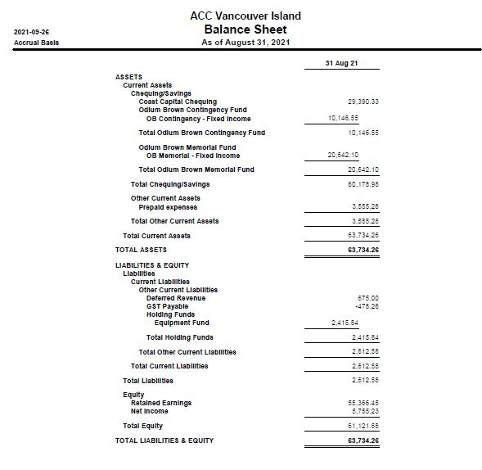

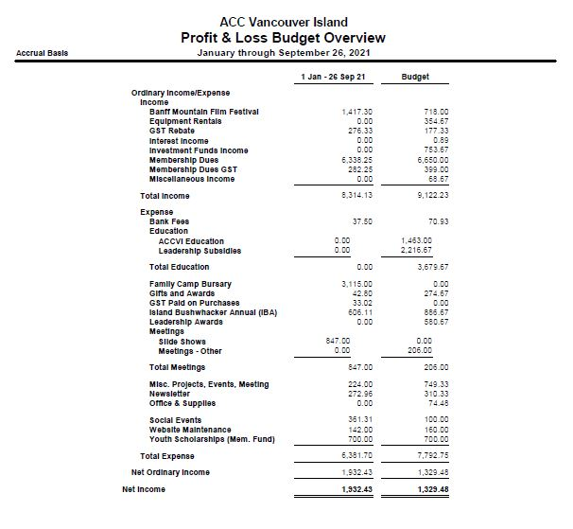

ACCVI Climbing Equipment Replacement and Treatment Policy

All helmets, harnesses, and ropes must be retired after 10 years of the manufactured date, providing that the manufacturer does not provide an earlier retirement date. Furthermore, equipment that does not meet the inspection criteria, detailed below, must be retired.

Always follow manufacturer's recommendations regarding equipment replacement and treatment.

Treatment of Equipment

Serial number and CE mark - Make sure that the serial number and CE mark are legible. Do not alter the tags.

Marking - Avoid chemical products such as Sharpie/permanent marker/paint on equipment surfaces. These are corrosive to all materials. Only write on a label of a different material.

Adhesives - Avoid applying tapes/stickers to equipment. Some tapes/stickers have harmful adhesives. Always follow manufacturer recommendations.

History - Any exceptional event regarding any equipment, should be recorded. The rope use log must be filled out and signed upon return.

Any equipment showing unexpected degradation should be quarantined, pending a detailed inspection.

Storage of Equipment

Location
Must be a temperate, dry place that is protected from UV rays and chemicals.

Before storing
Make sure equipment is dry. Air dry if necessary.
Clean and inspect equipment. When cleaning, always follow manufacturer recommendations.

Inspection Criteria
If the equipment exhibits of any of the following defects, wear, etc.., it must be retired.

Rope Criteria
- Verify that the product lifetime has not been exceeded.
- Know the rope's history (e.g., any lead falls reported in log).
- Look for:
- Sheath - cuts, burns, frayed strands, very fuzzy areas, signs of chemicals.
- Core - hard spots, swelling, soft or crushed areas.

Harness Criteria
- Worn off or no serial number and CE mark.
- Verify that the product lifetime has not been exceeded.
- Inspect:
- Straps/webbing/belay loop (Any soft materials on the harness)
Look for:
- cuts, swelling, damage and wear from overuse, heat, or contact with chemicals, frayed strands, very fuzzy areas.
Be sure to check the areas hidden by the buckles.
b. Adjustment buckles
Look for:
- marks, cracks, wear, deformation, corrosion, heat, breakage, contact with chemicals.
- Check that the straps are correctly threaded, with no twists.
- Verify that the buckles operate properly.

Helmet Criteria
- Worn off or no serial number and CE mark.
- Verify that the product lifetime has not been exceeded.
- Look for:
a. Shell(condition of the outside of the shell)
- marks, impacts, deformation, cracks, burns, wear, signs of chemical products.
- Liner (inside of the shell)
- marks, deformation, cracks, missing parts, breakage.
- Remove the comfort parts to inspect the hidden areas.
WARNING: Do not remove the liner that is attached to the shell.
- Cradle (webbing head harness/headband/adjustment system/chin strap)
- wear, cuts, burns, deformation of plastic pieces, missing parts, contact with chemicals, frayed strands, very fuzzy areas.
Move the keepers and plastic pieces to inspect any hidden areas on the straps.

