ACC – VI executive Monday 17 January 2022 7.00 pm by Zoom

Minutes

Present: Catrin Brown, David Lemon, Barb Baker, Laura Darling, Martin Hofmann, Garth Stewart, Josh Slatkoff, Jane Maduke, K T Shum, Mike Hubbard, Janelle Curtis, Graham Smith

Meeting called to order at 7:07 pm

1. Adoption of the agenda
Moved: Mike Hubbard; Second: Barb Baker. Carried.

2. Adoption of the minutes of the executive meeting 1 November 2021
One correction noted. Moved: Mike Hubbard; Second: Graham smith. Carried as corrected.

3. Matters arising:
- Acknowledgements for donations have been received from some of the organizations and are listed in the attachments.
- The website will be updated to show this year’s list of donation recipients.
- The changes at FMCBC may mean more attention on their part to Island issues.
- The current PHO restrictions mean the AGM would have to be virtual. A hybrid (in-person and virtual) event would be preferable, which could be possible if the AGM were postponed. For now, the date will be kept at February 11th, pending an update from the PHO.

4. Finance Update Garth
Statements to the end of December are attached. Financially, the section is in good shape. There was a net income of $1700 vs. the budget expectation of a $4900 loss. Expenses were down because many programs were reduced or did not occur. The on-line BMFF brought in $500 more than the budget amount of $1000. Meeting costs were up because of the camera and other equipment purchased for the virtual part of the slide shows. The section’s total equity is $58.5K, with $37K in the investment funds and $26K in the chequing account, which includes $4.5K for the equipment fund.

5. AGM Planning Catrin
- The draft budget for 2022 (attached) was presented for discussion. It projects a loss of about $4500, which could change significantly as there is uncertainty in the projected revenue from the BCMFF. The amount for the family camp bursaries has been increased as there was a specific donation for that. The finances for the Summer Camp and the hut will be presented as separate reports (any large program such as ski camps would also be reported with the Summer Camp report, but none took place in 2021). Garth will finalize the 2022 budget and circulate it for email approval before the AGM.

Motion: That all club payments be made by e-transfer rather than by cheque effective 1 January 2022.
Moved: Garth Stewart; Second: Martin Hofmann. Carried.

- For the AGM agenda, all reports will be compiled and posted in Discourse, and all presentation slides should be sent to Catrin to be assembled in one file to make presentation easier.
- Nominations for the next executive: Catrin is stepping down and David Lemon has agreed to stand for chair. He has requested that, if elected, there be provision for a past or vice-chair position to cover for absences from some travel he is hoping to do this year. This will leave the position of secretary to be filled; all other positions have nominees.

6. BCMFF Laura
The live showing has been moved to April 3rd, evening only because of the current restrictions. Depending on capacity rules and ticket sales, we have the option to reinstate the matinee showing if there is enough demand for tickets. Laura is working with Joanna Verano to promote the show via Facebook. Promotion is focusing on the in-person event rather than the on-line version. The posters that were made to advertise the event and distributed to store and UVic will be revised with the new date.

7. Island Bushwhacker Annual 2021 Catrin, Janelle
Contributions for the 2021 edition are due at the end of January. Robie Macdonald is no longer able to produce the Bushwhacker; Janelle Curtis is taking it over. Submissions for the next edition are urgently required. The 2022 edition will be the 50th anniversary for the Bushwhacker. To mark the occasion, Robie has suggested it feature comparisons of historic and contemporary photos of Island alpine areas.

8. Access and Environment Barb
We are still awaiting the renewal of the access agreement with Mosaic; we’re hoping to add the Ash River and it looks favourable so far. Barb will be writing a letter to Mosaic about the fact that gates are currently all closed and to inquire about the status of talks with the province about restoration of more access.

9. Summer Camp Laura
Suggestions from the Summer Camp committee for revisions to the equipment cost policy (attached) were discussed. Issues considered were how to fund the eventual replacement of the large dome tents, and whether the $30 equipment fee charged for the camp participants is sufficient. No decision was made on the recommendation to create a depreciation report, although reservations were expressed about its feasibility. A summary Summer Camp cost spreadsheet will be included as an addition to the Treasurer’s report at the AGM.

Motion: That the equipment charge for summer camp be increased to $50 as $20 per dome tent per person per week and $10 per person per week for other camp equipment.
Moved: Mike Hubbard; Second Catrin Brown. Carried.

Motion: That summer camp surpluses not be refunded, but added to the equipment fund.
Moved: Mike Hubbard; Second: KT Shum. Defeated 8 – 4.

Motion: That the threshold for the refund of surpluses or additional payments for shortfalls in the summer camp fee policy be raised to 10%.
Moved: Martin Hofmann; Second: Mike Hubbard. Carried.

10. National Club Update Christine
The national club is recruiting for a new executive director. Anyone interested in applying should contact Christine.

11. Website Jane/Evan
No report needed.

12. Hišimy̓awiƛ Martin
Barb has made inquiries about getting a parking are plowed out.

13. Donations to Club Library Catrin
Some historic copies of the ACC Journal have been donated to the library.

14. Any Other Business
None.

15. Next Meeting
To be determined after the aGM.

Meeting adjourned at 9:23pm

Attachments

Responses from recipients of donations

1. FMCBC
Hi Catrin. As President of the Federation of Mountain Clubs of BC, it gives me great pleasure to thank you and your ACC-VI for their generous gift of $500 to FMCBC. I want you to know that FMCBC really appreciates this support. It was great to have a discussion with you and I look forward to receiving from you some specific suggestions about trails on Vancouver Island that FMCBC could support. I take to heart your comments that FMCBC is too Lower Mainland centric.
I look forward to continuing to work collaboratively with your group.
Take good care and here's wishing you and your association a very Happy Christmas and all the very best for 2022.
Cheers
Liz.
Liz Bicknell (she/her)
President Federation of Mountain Clubs of BC
www.mountainclubs.org

2. VITA
Hi Caitrin. Thank you so much for your donation of $1000. Most generous given these tough fiscal and crazy times we find ourselves living in.
Here’s wishing you, your Board and family a very Happy Christmas and the very best for 2022. I look forward to hiking on the Vancouver Island Trail with you at some stage in the not too distant future.
Take good care and stay safe and well.
Liz

3. AFA
Dear Alpine Club of Canada - Vancouver Island!
Thank you for your donation of $200.00 to the Ancient Forest Alliance on December 28, 2021. We greatly appreciate your support.
Has your group signed on to the resolution? We are striving to reach out to a variety of groups/companies/organizations to Sign the Resolution - if you have any question, please email: info@ancientforestalliance.org
With a new, science-based roadmap recently released by the BC government to protect at-risk old-growth and with international pressure building to halt forest degradation, we’re feeling increasingly optimistic about the fate of endangered ancient forests in BC. But there is still much work to be done to ensure they’re fully protected.
Your gift today will help us support First Nations partners in developing Indigenous Protected Area proposals that conserve old-growth; continue to explore and document the beauty and destruction of old-growth forests; build and strengthen relationships with non-traditional allies; and pressure the BC government to commit funding toward Indigenous-led conservation, sustainable economic alternatives to old-growth logging, and the transition to a sustainable, second-growth forest sector.
You are an integral part of our team and we could not do this important work without you. Thank you for your generosity and support.
With all our gratitude,
~ The AFA Team
Please accept this email as an acknowledgement of your donation; AFA is a registered BC Society and is not eligible to issue tax-deductible receipts.

Did not hear from :

Marmot Recovery Foundation
CAJ
Strathcona Wilderness Institute
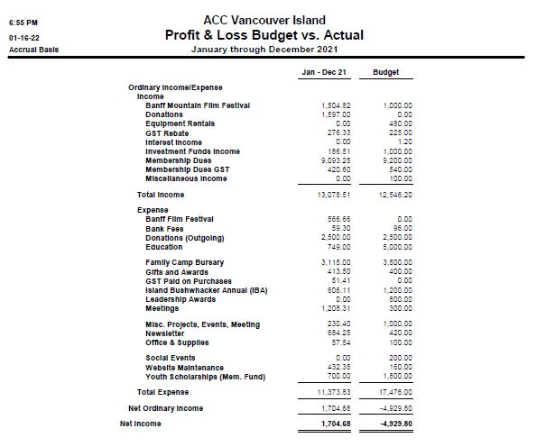

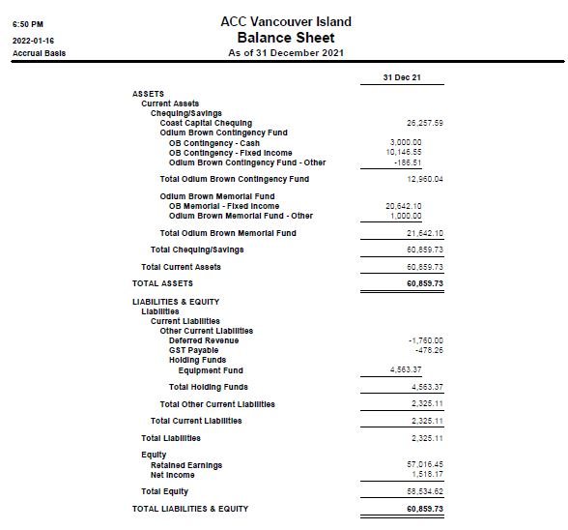

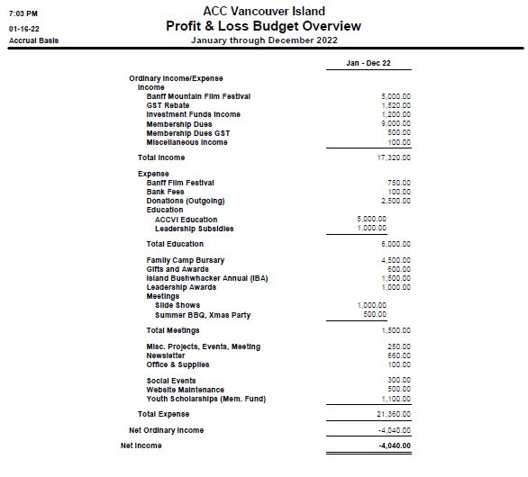

Proposal from the Summer Camp Committee to the ACCVI Executive
Prepared for the November 1, 2021 Executive Meeting

Background
In September a number of ‘Summer Camp Elders’ were asked for input to the Summer Camp budgeting process because the 2021 Griswold camp had been in deficit, and it was necessary to balance the books. While the existing policy* allowed us to ask for more money from each camper, it was a cumbersome and time-consuming process.

Recommendations from the Elders included:
- Create an equipment depreciation report (or document depreciation somehow, as a generally accepted accounting principle) in order to anticipate eventual replacement costs, especially of the two large tents.
- Increase the $30 equipment charge (based on a depreciation report and anticipating the need for new equipment, e.g. buying a trailer).
- Do not refund surpluses, but add any surplus to the equipment fund.
- Include the Summer Camp financial statement as a stand-alone cost centre in the ACCVI annual financial report (cf. reporting on the Hut finances).

The Elders did not agree on whether the shortfall policy* should remain. Some argue this policy ensures no future shortfall. Others argue this policy may result in some members or the Club subsidizing other members. Note: the SCC received excellent advice on how to better anticipate future costs.

Recommendations from the Summer Camp Committee to the ACCVI Executive:
- Accept all recommendations 1-4 from the Elders
- Repeal the shortfall policy.
_____________________________________________

*The current Exec-approved policy from our Information guide (https://accvi.ca/wp-content/uploads/ACCVI-Summer-Camp-General-Information-Guide-2020-final.pdf says:

i) if there is a surplus of >5% of the cost paid, participants will be refunded their share of the surplus. These amounts will be calculated and distributed in as timely a manner as possible after the final week of camp.
ii) ii) if there is a shortfall, participants will be asked for a contribution to make up the deficit. Again this calculation will be made in as timely a manner as possible after the final week of camp.
iii) In addition, the Exec approved that $30 per person be held towards the Equipment Fund.

