ACC – VI executive Thursday 13 May 2021 7.00 pm by Zoom

Minutes

Present: Catrin Brown, David Lemon, Mike Hubbard, Christine Fordham, Barb Baker, Laura Darling, Garth Stewart, Josh Slatkoff, Janelle Curtis, Liz Williams, Jane Maduke, K T Shum, Evan Devault, Liz Williams, Graham Smith, Derek Sou

Meeting called to order at 7:04 pm

1. Adoption of the agenda
Motion: Mike Hubbard; Second: Garth Stewart. Carried.

2. Adoption of the minutes of the executive meeting 22 March 2021
Motion: Mike Hubbard; Second: Christine Fordham. Carried. Minutes ready to be posted to website.

3. Matters arising:
- Island Bushwhacker Annual 2020 has been available online for a week. There have been 40 requests to purchase the print copy; 55 have been produced at a cost of $1082 for software and printing, included in the budget.
- 3-year membership requirement for IQ and CT 6000 plaques was revisited:
Motion: That the motion for the 3-year membership requirement for IQ and CT 6000 plaques be repealed. Moved: Christine Fordham; Second: Mike Hubbard. Carried.
- The “Benefits of Membership” document is still under development.

4. Finance Update Garth
There has been little activity in the finance area. Revenue from the BMFF so far is $1417. Membership dues are holding steady. The Island Bushwhacker costs are much reduced. $700 has been paid from the Memorial Scholarship fund. See attached statements.

5. Education and Leadership Catrin
The committee has been set up and has begun its work; see attached document. Work on website updates is also under way. Education and leadership activities are largely on hold for COVID, so this is a good time to update documents and program ideas (possibly virtual workshops if anyone wishes to present one). KT is looking for resources to add (websites, books, etc.). Laura mentioned that the Calgary and Rocky Mountain Sections have a very good set of resources on their sites, as an example.

6. BCMFF Laura
We have a little over $1400 in revenue so far. Purchases have slowed down considerably, so that is not likely to increase by much. There is no information to date on plans for next year’s festival; it may be in early 2023. We have some tentative UVic bookings, but it is not clear what occupancy will be possible. The situation remains very uncertain.

7. Access and Environment Barb
We have sent a letter to the Alberni-Clayoquot Regional District about the need to replace the Franklin River bridge; a decision is expected by the end of May. The Mosaic website now shows gate opening hours of 8AM to 8PM. The Regional District of Nanaimo is working on a survey for an historic trail to Horne Lake from Port Alberni. There has been no response so far to the RSTBC application for hut trail sign improvements and sanitation at Cobalt Lake. Colleen Kasting is working on more funding applications for hut trail improvements, as well as other funding for the hut. The closure means there is no revenue coming in from hut fees and there are repairs needed for which there is no money left in the hut account; therefore grants, etc. are being sought for that purpose.

8. National Christine
There has been little activity. There is a Section Council meeting this weekend; most sections are at a low level of activity. There were 19 North Face applicants of which 10 were selected. It is not known if our section applicant Kara was selected. The National club AGM will be held May 15th, by Zoom.

9. Trips for Specific Groups Janelle
Janelle has been leading beginner trips for women only, and there seems to be continuing interest in them. What is the section’s position on special trips of this sort? There have been several types of specific trips held previously: youth, Trailriders, recent immigrants, LGBTQ, women, etc. These have been a way encouraging members from groups that otherwise would maybe not likely to join. There was discussion of the concept, but the general feeling was that these special trip types are OK for encouraging membership from under-represented groups, as long as there are enough open trips that everyone can participate in.

10. New Additions to Website Catrin
The section has received some memoirs and stories from senior members, and the question is what to do with them. A section of the website for section history and memories was deemed desirable if it can be done. Lindsay Elms has been compiling the section history, and a map showing Indigenous names for Island mountains is also being developed. Evan and Jane think that such things can easily be added to the website, perhaps by adding a history tab to the “About US” section and putting the Indigenous names map under “Information for Members”.

11. Information Items (Updates) Catrin
- The youth grant from the Memorial fund awarded last year, but postponed due to COVID will be taken up this year.
- First Nations names map: to be added to website, see §10 above.
- Septimus/Rosseau IQ query: there has been long-standing confusion as to which is higher, and which one is the actual IQ. Many people have climbed Rosseau instead of Septimus, thinking it was the correct one. This would be a good item for a newsletter article.
Don Forest award: Geoff Bennett has received this award for service to the club from National.

12. Planning ahead
Much uncertainty remains in the pandemic situation, and the future trip schedule depends on the status of the Provincial Health Orders after the May 25th expected revision. Summer camp will be contingent on whether distancing is still required; the camp committee will make its decision in mid-June.
Online slide shows are booked for June and September (there will be none in July and August); Catrin is still looking for someone to take over organizing the online shows.
There may be no need for another executive meeting before the fall, unless it proves necessary to consider how to deal with any changes in the PHO.
17. Any other business
None; meeting adjourned at ~9:00pm

18. Next Meeting

TBD.

Attachments

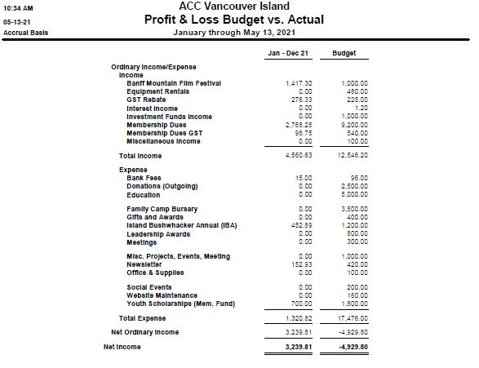

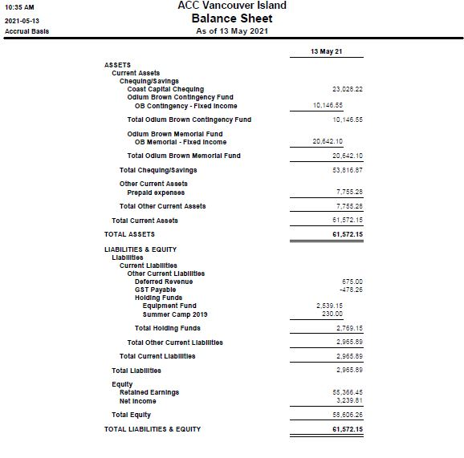

ACC-VI Education and Leadership committee

1. Committee people and interests
Iain Sou - education coordinator
Christine Fordham - leadership recognition, national rep
KT Shum - picking up above from Christine, interested in other aspects of record keeping
Tana Jukes - new and open to helping, unsure of time commitment
Jane Maduke - webmaster, interested in maintaining and updating relevant sections of website
Catrin Brown - ACC-VI chair

2. Trip leaders
- review of expectations and guidelines
- review trip descriptors and expectations of participants re courses done etc.
need to review and possibly update the trip descriptors and include them in the leadership section as well as the schedule page; worth checking what other sections and clubs have on their sites
- mentorship and orientation of new trip leaders
mentorship is best done informally with people seeking and receiving support from leaders who they know; scheduler can also suggest introductions

Action points
- KT and Catrin (input from any others welcome) to review the wording on the ‘Info for Trip Leaders’ section of website, reorganising so that content matches drop down menu. Remove mention/email address of mentorship.
- KT and Catrin will work with Jane to update the website.

3. Trip leader incentives
i) course subsidies
review guidelines and record keeping
allocation of budget $3000
program reviewed and updated fairly recently, seems in good order.

ii) recognition points
review guidelines and record keeping
review of prizes - SWAG, badges, gift vouchers
allocation of budget $800

KT has taken over record keeping;
discussion about prizes - top leader prize jacket seems successful incentive, vouchers vs SWAG for other prizes discussed, with point raised that SWAG is overdone in some fields;
discussed stickers instead of cloth badges

After the meeting Catrin thought about other prizes such as the Petzl manuals for summer and winter leadership, vouchers for climbing gyms etc.

Action points:
- Christine and/or KT to investigate sticker and possibly SWAG purchase options
- Consider prizes based on thresholds of points rather than competition, especially given Covid reductions in our schedule

4. Education Program
- discuss schedule of courses and workshops
Iain plans to offer courses similar to previous years, all Covid depending;
workshops not yet planned and would depend on volunteer leaders

- review membership discounts for courses - budget $2000
previously been used for certain courses including First Aid; possibility of using some of this to fund virtual workshops, which could also reach a larger number of people

- virtual education offerings
idea discussed and supported, dependent on volunteers

Action points:
- Iain to send email to membership asking for interest in people offering a virtual workshop on any topic relevant to trip leadership and safety.
- Iain also to contact possible providers such as Alert First Aid and Archetypal (Ken Wylie) to check their availability for a virtual workshop with some financial compensation

5. Scheduling other events
- slideshows
- social events

The role of an “Events Coordinator” was suggested, with responsibilty for the annual calendar of events. Does not have to be someone from this committee.

