ACC – Vancouver Island Section
2019 Annual General Meeting: Draft minutes
7:00 pm Saturday 2nd February 2019, Vancouver Island Mountain Centre
______________________________________________________________________________
Meeting called to order at 6: 58pm.
- Adoption of the agenda
Moved: Mike Hubbard; Second: Nadja Steiner. Carried

- Adoption of the minutes of the 2018 AGM
Moved: Derek Sou; Second: Christine Fordham. Carried.

- Reports:
Chair’s Report: Catrin Brown
The chair reviewed and summarized the year’s activities, using the structure of a tree as an analogy for the growth and thriving of the club; for details, see attached.
Treasurer’s Report: Clarke Gourlay
Financial reports for 2018 and proposed budget for 2019 are attached. For 2018, the main item to note is a small deficit due to donation for completion of the 5040 hut; revenues from the Banff Mountain Film Festival are expected to erase that shortly. Other notes: education is now shown only as an expense entry, and equipment rental revenues have been consolidated.
Motion to accept the 2018 financial report
Moved: Roger Taylor; Second Geoff Bennett. Carried
Motion to accept the 2019 budget
Moved: Colin Mann; Second Derek Sou

Memorial Fund: Geoff Bennett
See attached
Education: Colin Mann / Alois Schonenberger

National Club: Christine Fordham
See attached

Newsletter: Mary Sanseverino
See attached

Membership: Kathy Kutzer
See attached

Website: Martin Hoffmann & Jessica Scott
The hut website has been integrated into the section website. Qualified trip leaders now have direct access to the schedule to post their own trips if desired; posting through the schedule coordinator continues to be available as well.

Environment and Access: Barb Baker
See attached; private forestry land access remains the biggest issue.

FMCBC: Anya Reid
See attached

Youth Program: Derek Sou
See attached; the program has been highly successful in encouraging family participation.

Banff Mountain Film Festival: Annaliena Steiner & Lise Gagnon
Consideration should be given to running a second night in future, as the event sold out very quickly, largely through social media advertising. The displays in the lobby in future will have a greater proportion of relevant non-profit organizations.

Leadership: Natasha Salway
See report,

Equipment: Mike Hubbard
See report

Hut Committee: Chris Jensen
Construction is essentially complete, and responsibility for the hut will now transition from the building committee to an operating committee, which is being formed. Construction came in on budget at approximately $300,000, with 400 volunteers assisting in the construction. A section hut week is scheduled for August 17 – 25, 2019. The province has issued a permit for improvements to the Cobalt Lake trail up to the hut. An narrative of the hut construction is in the file 2019 ACC AGM - HutV2.pdf.

- New Business
None.

- Leadership Awards Awards for trip leadership at various levels were distributed by Natasha Salway and Colin Mann. As the number of points scored by the two top leaders was so close, two Arcteryx jackets, embroidered with the ‘top trip leader’ logo were awarded this year. Congratulations to Alois Schonenberger and Walter Moar for being our top leaders.

- Nominations Report Mike Hubbard
See attached report.
The positions of Chair, Treasurer and Secretary were filed by acclamation. The balance of the nominations were acclaimed as a group.

Motion to accept the new executive by acclamation.
Moved: Mike Hubbard; Second Roger Taylor: Carried.

- Presentations
Photograph books of the 5040 hut construction were presented to Chris Jensen and Chris Ruttan in recognition of their exceptional service and efforts in seeing the construction of the hut through to a successful conclusion.
Robert Ramsay was presented with the ‘Rick Eppler Island Qualifiers Award’ plaque for his successful completion of all the Island Qualifier peaks in 2018.

- Any Other Business
None.
- Announcements
The 2019 summer camp will be held in the Stein Valley; further information to come.
The submission deadline for the 2018 Bushwhacker Annual is February 28th.
- Meeting adjourned at 9:15 pm

Attachments
Chair’s Report: Catrin Brown
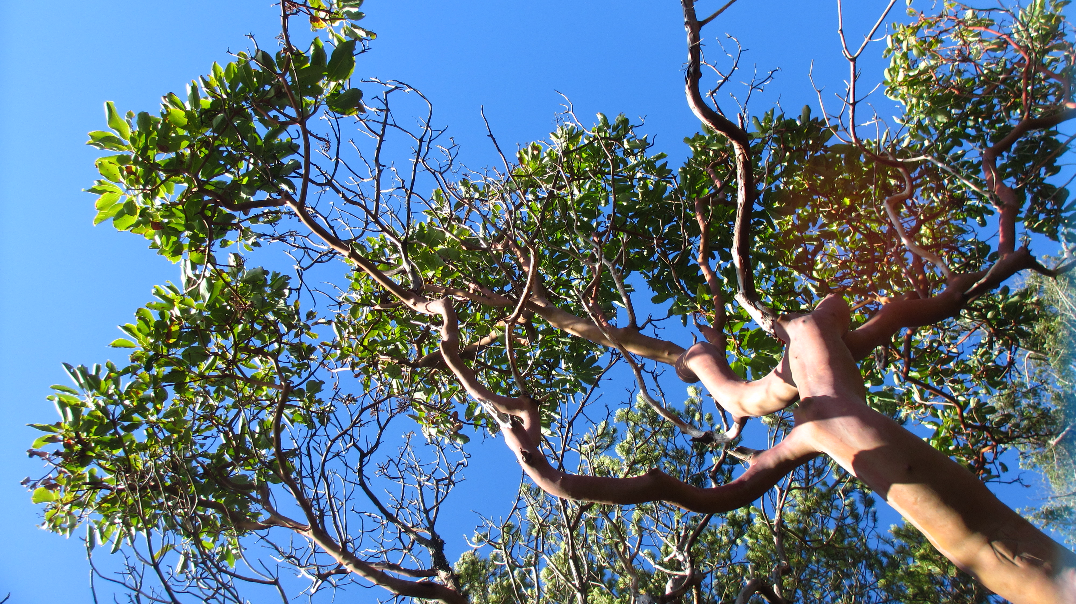
In trying to summarise our section’s activities in 2018, I’m going to use the image of a tree. I’ll leave you to build the image into whatever tree you think is the best fit for our ACC-VI section at this time. To start with, your tree must be strong and healthy, thriving actually in all its parts.
The top of the tree, known as the crown, with the multitude of leaves and shoots is the most active and recognisable part. This represents our many and various activities. Clearly our tree is evergreen because it is active in all seasons, all weathers.
Many of our activities come from the trip schedule –often known as our life-blood, or should I say sap? In 2018 scheduled trips included a wonderful array of activities including, just as examples, many day trips all over the Island, two climbing camps in the summer months, a ski week camp and traverses, four – yes four, weeks of summer camp in the Coast mountains. I think it fair to say there was something for everyone. And for all of this we are really grateful to the many trip leaders and to the summer camp committee who step forward and make it happen. These are generous people – they spend their time, and share their energy and expertise to pass on their passion. Many thanks to you all – and please keep leading! And the rest of you, please consider adding a trip to the offerings, new leaders are always most welcome. Outside the schedule, our members are out there pursuing their interests in all kinds of ways, from appreciating spring flowers to pushing new frontiers of exploration in the mountains. In March Chris Jensen, Ryan van Horne and Hunter Lee climbed a new ice route on the north face of Elkhorn.
In the spring, Evan de Vault and Stefan Gessinger completed a traverse from Bedwell lake to Bedwell Sound, which included possible first winter ascents of Tom Taylor and Mariner. Stefan also with Francis Bruhwiler completed a 5040-Jacks-Adder ski traverse in one day, with what Stefan called some of the best skiing he has ever had on the island.

Meanwhile, Isobel Glover became possibly the first woman to hike the entire length of the Island, and the first person to complete the entire route of the so-called Spine Trail. Her adventure is beautifully written up in the publication “Aspects”, very well recommended reading.
In 2018 the crown of our tree grew some new branches, and strengthened branches that reach in new directions.
- Our attempts to offer trips to new immigrants have gained traction with a growing relationship with the Inter Cultural Association of Victoria, and we have fun plans to take new immigrant youth into the snow in the coming weeks. Thanks to Karun Thanjuvar.
- Our trips advertised for people from the LGBTQ community have continued, the high demand for these trips tells you everything you need to know about their importance in our goal of becoming ever more inclusive and diverse. Thank you especially to Jes Scott.
- In a similar vein, our “Wild Women’s” adventures have maintained an active pace with trips to Rugged Mountain, Arrowsmith, and Crest Creek Crags. I’m told one of the leaders and strongest climbers of a climbing weeekend was 6 months preganant - as they say, don’t try this at home! Thanks to Brianna, Jes, Lenka and Janelle.
- Some of the shoots in the crown of our tree have buds which are growing rapidly and opening into new shoots. Yes our youth program is a truly vital, energetic and inspiring part of our offerings. Big thanks to Derek Sou and Stefan Gessinger for sowing seeds in our youth, giving them such extraordinary experiences. They will never forget it.
- Our Trail Rider trips have continued to offer opportunites to people who could not otherwise access wilderness, and they always bring the special camaraderie of team work. If you have not done so yet, I encourage you to sign up for one of these trips – it is a delightful experience. Our thanks to Caroline Tansley for her commitment to this.

All these trips for specific groups are well described on our website, and the diversity of our offerings caught the eye of the National, leading to a featured piece in their blog during the summer. Well done us, this diversity is truly something to celebrate.
With thanks to Alois Schonenberger and Colin Mann, our education program continues to offer opportunities to strengthen our green shoots. The range of offerings is impressive, as is the subsidy program, which hopefully makes the courses accessible to all, and promotes new leadership in the same stroke.
Some parts of the crown of the tree are a little more protected from the elements - as indeed are our indoor activities. Our monthly Swan Lake slide shows, photo contest, Christmas parties, summer barbecue, AGM weekend - all help to bring us together, to build community, entertain, inspire us - and sometimes even to feed us. Thanks to Peggy Taylor and Neil Han for your reliable organisation, and to Clarke Gourlay, Tom Hall, Mike Hubbard and Colleen Kasting for your generosity in opening your homes to the hordes.

The next part of the tree, the stem or trunk, is also active, but in a less visible way, supporting and nourishing the activities in the crown. This seems to me a good description of how our executive works. Take it from me, they are a terrific team – fun, reliable, caring and creative.
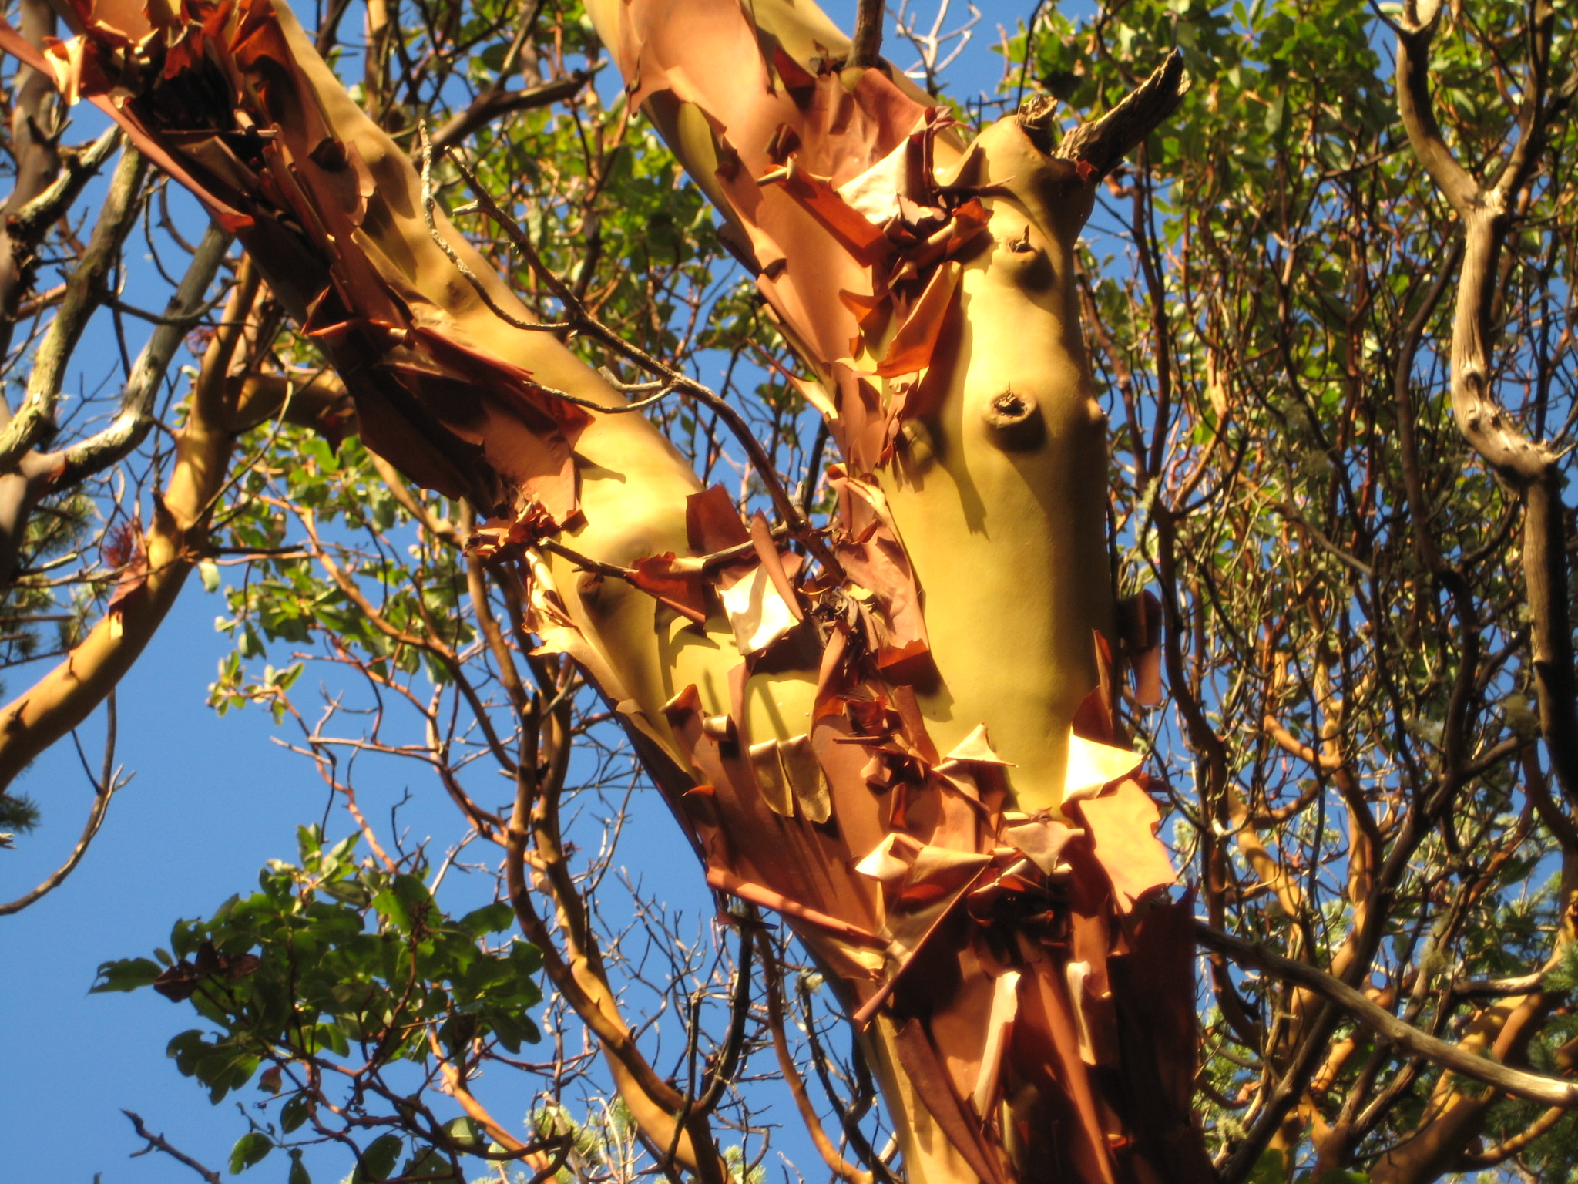

Communication is a key function of the executive and we take a multi-pronged approach, including our website, monthly bulletins, seasonal newsletters, annual journal, email lists and social media. The coordination of all this, with maintaining membership lists, our trip schedule, minutes of meetings etc is a task in itself. Thanks to Jes, Martin, Mary, Sean, Kathy, Karun and David.
And although we are a volunteer organisation, there are still costs and revenues to track. Happily our treasurer, Clarke Gourlay, is a master of doing exactly that, and deserves special gratitude for sharing his expertise generously. As we will see in the financial report, the income generated from hosting the Banff Mountain Film Festivals is crucial to our ability to fund so much of what we do. Amongst other things this means we are able to donate to causes that we feel are aligned with our mission. Our thanks to Lise Gagnon and Anna-Lena Steiner for achieving a sell-out crowd in record time this November. Whatever your magic formula is for success gals, please do it again next year!

And so on to the root of the tree, its oldest part. It anchors and ensures longevity, nourishes and provides support and storage. Well guess what, we are well rooted too. As members of one of the oldest clubs in Canada, and our own section dating back to 1912 (actually if you think about it, not much on the Island is older than that…) we have a rich history. It was a delight to congratulate long-time section member Gil Parker on his receipt of the Honorary Membership, the highest award in the ACC, in May, and later to congratulate Mike Hubbard, still actively serving on the executive, with his 50 year membership milestone. We have two awards, both named in memory of pioneering mountaineers in our section, the Rick Eppler IQ award and the Charles Turner 6000’ ers award, which serve to inspire us to get out there and continue their legacy. (And - spoiler alert - one more person will shortly join the ranks of the recipients.) In a related way, our memorial fund releases the means to encourage young shoots to grow through worthy expeditions – and 2018 was a phenomenol year for this, as you will hear in Geoff’s report to follow.
The communication between the tree’s root and crown must occur in both directions, which seems to reflect our relationship with the national club. Our activities are enriched by this storied affliation, and word has it that ACC-VI activities are valued contributions to the vibrancy and legacy of the main club too. Christine will say more about this in her report.
And to add to the analogy, the storage function of our roots includes archives, and significant amounts of gear that supports our many activities, from climbing trips to summer camps to slide shows. And of course all of this takes more volunteer time and energy to maintain. Thanks to Tom Hall, Mike Hubbard and Bernard Friesen.
And so I hope I have shown in this brief summary that the parts of our tree - the crown, the shoot and the roots - are strong indeed, thriving as I said.
But wait a minute I’m not done. Something else has been growing atop the tree in the last few years. It’s very prominent and beautiful, it’s drawn attention to our tree from far and wide, and it opened in full flower late in the year.
And that is - ? Yes, we have an ACC-VI section hut! The completion and official opening of the hut in October 2018 was indeed a landmark event, and for those of you who were up on the mountain that weekend will know what a happy celebration it was. More than one person afterwards told me they were moved to tears by the tributes, the accomplishment of such a disparate group who showed up and worked hard and collaboratively to get the job done. And done in such fine style. I’ll leave more to Chris’ report to follow – suffice for me to say that watching this project unfold with such careful thought, dedication and good humour has been an enormous privilege. Many people are to be credited with this, but Chris Jensen and Chris Ruttan are standouts in this outstanding crowd. Without doubt the 5040 Peak hut is already becoming an important expression of our mission and outreach, and a boost to mountaineering on the island. What a legacy is that.
And finally, we all know that trees, like people, do not thrive in isolation. While our tree is healthy and strong, we know it is dependent on its environment and we cannot be complacent about its needs. Perhaps the true life-blood of our section is actually our Island mountain environment – wild, beautiful, challenging and ever changing. We have so much to appreciate and share, and we need to return that appreciation to the land in whatever ways we can. From picking up random garbage, to supporting the various club iniatives on stewardship, joining interest groups and committtes, contributing to decisions about parks, development, continuing our push to engage landowners in access issues etc., there are ways we all can strive to contribute. And contribute we must. As some wise person said:
“There are no passengers on Spaceship Earth. We are all crew.”
Thanks for joining me on this little wander in the forest.

Financial Reports and Proposed 2019 Budget
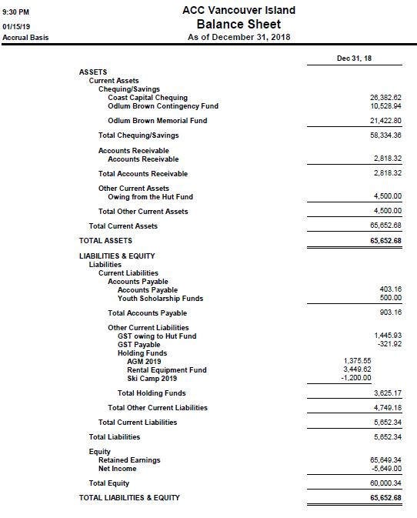

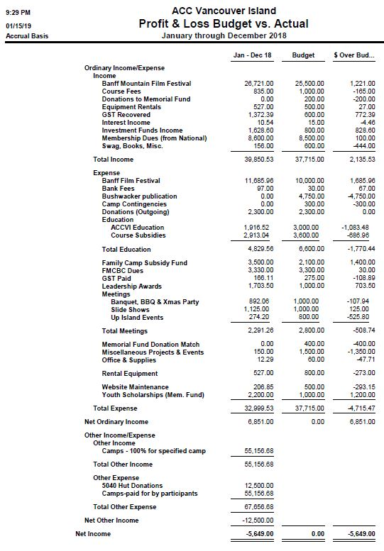
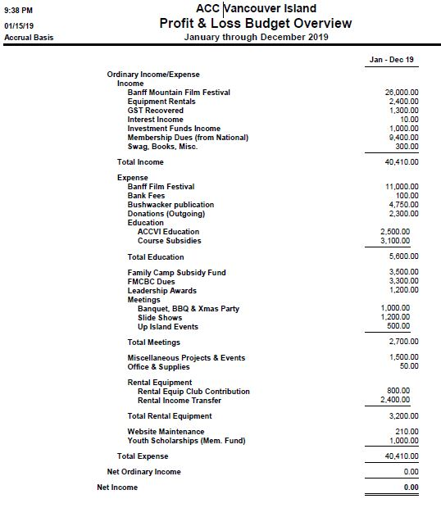

Memorial Fund
- Year end 2018 balance in Odlum Brown account $21,423
  - book value of corporate bonds (2): $20,642
  - cash: $781
- Total donations and matching section contributions since 2009: $20,230
- Total disbursements since 2009: $6,913 on 10 projects
  - An additional $962 has been contributed by the ACCVI Section (total $7,875)
  - The ACCVI Section is currently withholding a total of $500 from 5 recipients, pending receipt of Bushwhacker articles
- Total investment return since 2009: $8,106
- Funds available for disbursement in 2019:
  - Current balance in MF ($21,423) less capital ($20,230) = $1,193
  - However, the cash balance is $781, which is the maximum available for disbursement

CONTINGENCY FUND
- Original investment (2009): $10,000
- Year end 2018 balance in Odlum Brown account $10,529
  - market value of corporate bonds (2): $10,147
  - cash: $382 (available for deposit to the ACC Coast Capital account)

INVESTMENTS
- The CF and MF invest in the following corporate bonds through Odlum Brown:
- BROOKFIELD ASSET MANAGEMENT INC 3.95% 09APR19
  - Investment focus is on real estate, renewable power, infrastructure and private equity assets. They manage a range of public and private investment products and services for institutional and retail clients. They earn asset management income for doing so. They have over $30 billion of capital invested, primarily in four listed partnerships: Brookfield Property Partners, Brookfield Infrastructure Partners, Brookfield Renewable Partners and Brookfield Business Partners.
- ALLIED PROPERTIES REIT SR B 3.934% 14NOV22
  - A leading owner, manager and developer of (i) distinctive urban workspace in Canada’s major cities and (ii) network-dense urban data centres in Toronto that form Canada’s hub for global connectivity. Allied’s business is providing knowledge-based organizations with distinctive urban environments.
- GRANITE REIT Holdings Limited Partnership 3.873% S3 30NOV23
  - A Canadian-based Real Estate Investment Trust (REIT) engaged in the acquisition, development, ownership and management of predominantly industrial, warehouse and logistics properties in North America and Europe. Granite owns over 85 investment properties representing approximately 33 million square feet of leasable area.
Since inauguration in 2009 the Fund has disbursed $7,875 to ten different youth groups in the alpine:
- 2010 - $1,200 for the Brooks Peninsula Expedition (Gillian Nicol, Cory McGregor, Cody Gold, Derek Cronmiller)
- 2012 - $250 for first ascents on the SW Buttress of Mount Arrowsmith (James Pierzchalski)
- 2013 - $1,400 for a General Mountaineering Camp for youth at Mount Matchlee (Harry Steiner)
- 2013 - $600 for a first ascent of North Needle Peak in the Great Bear Rainforest (Christina Service, Laura Grant, Vernon Brown)
- 2015 - $925 for a study of weather conditions and climate change at 20 remote fire lookouts in the Rockies (Kristen Walsh)
- 2016 - $1,500 to purchase climbing gear for a First Nations youth rock climbing camp near Ucluelet (Carlos Mack)
- 2018 – $2,000 total
$700 for a Strathcona Park traverse including first winter ascents of Tom Taylor and Mariner (Evan DeVault)
$600 for a S-N hike of the entire VI Spine Trail (Isobel Glover)
$500 for a ski tour of Liberty Bell, Washington by the ACCVI youth group (Derek Sou)
$200 to purchase equipment for an expedition by Nanaimo Scouts to climb several major peaks in the UK (Andy Chapman-Coombs)

Education
In 2018 the Education Team coordinated a number of courses, offered through certified guides such as those who work for IAG, and ACCVI Volunteer-led workshops. These include Trip Planning, AST, Intro to Backcountry Skiing, Crevasse Rescue, Intro to Rock Climbing, Backcountry cooking, Intro to Mountaineering (Steep Snow skills), and Wilderness First Aid. We also updated our web content a little bit. Our course offerings in 2019 will look very similar, with a few exciting changes such as the use of the new 5040 hut to host our Steep Snow workshop, and the potential for a follow-up upgrade course for Advanced Wilderness First Aid. We continue to welcome members to approach us with potential ideas for new workshops, and we are more than happy to help develop the course objectives and make logistical arrangements if needed.

National Club
RESPECT THE MOUNTAINS DAY - June 15 – Work party combined with an - Environmental -Educational Component – Nationwide event all 24 sections participating – media coverage to draw attention to our fragile and beautiful mountain environment. Any ideas and help please email me natrep@accvi.ca
- Ideas to Date - Paradise Meadows trailhead at Ravens Lodge, perhaps approaching Strathcona Wilderness Institute assist as their mandate is education and mountain stewardship.
- Cobalt Lake Trail improvements rerouting (switch backs) and stabilization (Provincial authorization pending)
- Trail maintenance on the Judges Route.
- Mini-blitzes, trail maintenance around Victoria – Sooke Hills, Mt Work, Mt Finlayson,

HOW YOU CAN BENEFIT MORE NATIONALLY
- GMC’s, summer camp where members from all over Canada can mix. ACCVI is part of 24 very diverse and unique nationwide sections
- The North Face Summer Leadership Camp is March 22/19 –earlier is better as you need reference letters from Executive
- Educational and Environmental Awareness Info including:
* Mountains 101 online course is still available and free. Mountains 102 coming soon….
* A State of the Mountain’s Report 2018 - This first annual collection of expert summaries describes the abrupt effect of retreating glaciers on the flow of mountain rivers and watersheds. Sign up to blog posts to get latest reports that are released thorough out the year. Jan 2019 Avalanches
- The new IMIS Management System is online you can now-Edit your profile, to take advantage of all ACC services including subscribing to the weekly news net and printing your membership card.
NEWSFLASH - The Historic Abbot Pass Hut Reopening - ACC and Parks Canada have recognised value of the historic Abbot Pass Hut, gateway to Mt Victoria, Mt Lefroy and the Furman Ledges. This historic hut, the second highest in permanent structure in Canada, will re-open in Spring.
Thank you to our members who sit on other National Committees:
- Mary Sanseverino - Nominations Advisory Committee
- Alois Schonenberger- Leadership Development Committee
- Brianna Cook-Coates - Leadership Development Committee

Newsletter
The Island Bushwhacker Newsletter continues publication under the schedule agreed upon at the 2018 AGM. Publication of the newsletter occurs four times a year: March, June, Sept, and December. The other 8 months of the year an email news bulletin called the ACC-VI High Points is produced and distributed.
Approximately 450 ACC-VI members receive both the Island Bushwhacker Newsletter and the High Points email in their inbox. Many more people, both members of the section and others, get notification of the Newsletter via the ACC-VI Facebook Page. The current edition and past editions are available online at the ACC-VI website.
In closing let me ask members to consider sending in mountain-related articles, announcements, trip reports, websites and links of interest, book reviews, photos, etc. In the past I’ve relied pretty heavily on a handful of people to keep us informed on mountain themes - especially mountain adventures here on Vancouver Island. I know that many more members are out and doing things in the hills. It would be wonderful if more people could step up and offer contributions. Don’t worry about length, spelling, grammar, maps, etc. - I’ve got you covered!
Looking forward to seeing you all in the hills, or, at the very least, reading about your adventures in the Island Bushwhacker Newsletter.
Membership
TOTAL MEMBERS: 704
Individual Memberships: 325
Student Members (1 UVic Student Membership): 48
Lifetime Memberships: 8
Youth: 2
Family Members: 320
Family Memberships: 130
Member Locations
South Island (Malahat South up to Port Renfrew, Including Salt Spring): 392
Central Island (Malahat to Cambell River): 206
North Island (Sayward North): 0
West Coast (Port Alberni West, including Tahsis): 18
Outside of VI Area: 88
Unknown: 0
Updates: - More members than last year (491 in 2018)
- National no longer providing membership cards. They can be printed off from your ACC “profile” account

Environment and Access
ACC National Access has a somewhat dated blog with a few postings on access stories of national interest. Their Environment Section is much more active and worth a visit to the scholarly articles on the state of Canadian glaciers, ice core archive, mountain birds as examples. Lael Parrot, VP Access & Environment lives & works in BC.
Local Report:
IslandTimberlands Timberwest operations merger is now called Mosaic with a new website.
Manager there who was a good contact has retired. Access plans discussed with us in Nov 2017 shelved. They are now asking for a land use application much the same as the CDMC/Timberwest agreement which I have stated is not what we were tentatively offered & too cumbersome for our membership.
This subject was on their weekly Access Discussion Jan 29 but no results from them at this writing.
Land Access announcements have been kept up weekly but not always accurate.
Logging over the Inlet Trail for some months both Stage 1 & 2. No weekday access & no weekday road access on any of their lands.
BCTS FLNRO… discussion sessions annually to look at imminent & future harvest plans but no public posting of daily situations. For up to date info, call South Island Forest District Nick Clarke.
Waiting for details on Br. 600 obstacles to the Nahmint Brook George Klitsa Trail where there is logging
now.
Klitsa North approach….road has been rebuilt, then deactivated. Estimated 5 + km road walk to trail.
AV Community Forest road to Adder…. their policy is to facilitate access! Great response on
recontouring water bars late fall.
Please feel free to suggest others areas of concern on Access & Environment subjects.

FMCBC
- Anya attended the FMCBC AGM June 9th in Victoria.
- The main issue discussed was that currently there is one representative from each club on the FMCBC Board of Directors, this is cumbersome because there are about 40 clubs.
- It was proposed that the FMCBC Bylaws be amended to establish a Board of Directors consisting of 4 Officers and no more than 7 additional Directors. This passed and is underway.
- ACC-VI purchased trail markers from the Federation, which were used on the trail to the 5040 Hut.
- ACC-VI received a $1,000 grant from FMCBC for the construction of the 5040 Hut composting toilet system.
- The ACC-VI Branch pays $10 per member to be part of the FMCBC, this does not include insurance (which is provided by National).
- The exec is currently considered whether this fee is justified and is providing adequate value to ACC-VI members.

Youth Program
As Program Coordinator, it is my pleasure to announce that the Kids and Youth Program (the “Program”) went on 10 trips in 2018:
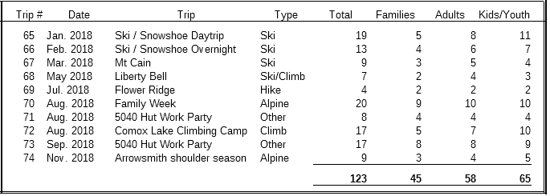

These trips were led by either me or Stefan or both of us. My son, Iain, assisted the leaders on the trips he came on, except for the last trip where Savannah Miles, the Program’s freshly trained youth leader did the honours. Savannah attended the Family Week and all the following trips, as well as completing a 13-part youth leader training curriculum developed by me and a Red Cross wilderness first aid course.

We had 15 different families and a total of 24 different kids/youth, ranging from ages 7 to 18, come out on our trips. 4 families came on one trip, 5 on two trips, 2 on three trips, and 1 on each of five, eight and ten trips. Our largest trip was Family Week with 20 participants, 10 of which were kids/youth.

Here’s a summary of our year published in the Aspects blog post:

2018 has been a year filled with adventure for the ACCVI's Kids and Youth Program. Winter was filled with three ski trips, one of which was an overnight ski trip that lasted a mere 23 hours due to an un-forecasted 60cm of snowfall over 5 hours. In the spring we transitioned to climbing, but made it on skis by skinning up to South Early Winters Spire in Washington State where we camped for the night. We climbed the spire the following day and skied back to the cars in time to view the setting sun over the spire.

Summer comprised some hikes, a hut work party, and a climbing camp, but the highlight was the Dugong Peak Section Camp. In the first Family Week of the Vancouver Island Section Camp we got 17 of the 20 kids and parents participating up summits, we ice climbed seracs, rock climbed on slab, gorgeous cracks, and up a multi-pitch route. The location was magnificent with great access and many lofty goals; it even had a sandy beach. The end of the week was perhaps the sweetest fueled by the high from successful summits bids. We truly hit our groove on the last day when we ice climbed in the morning, ate lunch at camp and rock climbed into the evening. We came back safe, friends, and full appreciation and fond memories

At the tail end of the year Sonia announced that she would like to start an extension of the Program called Trips with Toddlers. Now kids could potentially graduate high school with up to 17 years in the ACC!

We are off to a great start this year with three trips in one weekend in January: a ski/snowshoe trip led by Stefan with 9 participants, one by me with 14 participants and an outing by Sonia’s Trips with Toddlers.

I would like to conclude by acknowledging the support of the executive for the Memorial Fund Youth Grant for our Liberty Bell trip in May, continued bursaries for Family Week and providing free gear rentals for Kids and Youth trips, which included ropes, harnesses, helmets, crampons, and snowshoes this year.

Leadership
I want to thank all the leaders who put trips up on the schedule in 2018. We had a very successful year with 54 leaders putting up trips and a total of 265.5 points accumulated by all leaders. Funny enough, those two numbers match 2017 exactly!
The only difference was the top leader in 2018 earned 29 points and 2017 was 31.5.
This year saw the addition of established leaders, who have obtained 5 points or greater, being able to post directly to the ACCVI schedule. We hope that this will make it easier on our leaders and give them more control for planning their trips. These posts are being monitored for content and quality by the schedule and leadership team.
I want to draw attention to 2 very useful tools on the website. Under the Info for Trip Leaders: Checklist, there is a trip planning template. We encourage all trip leaders to use this template when they do their write ups for the schedule. Whether you are sending it to the scheduler or posting it yourself, this template will cover all the bases that you should include in your trip post. There is also another template spread sheet a little further down the page that is great for keeping track of your participants and waiting list as people email you. Feel free to download both and use them.
We are working on one more document which will be an Emergency Trip Plan. We would like all of our leaders to consider leaving behind a detailed emergency plan with a trusted person, whenever they head out on trips. I know I can speak for SAR and Wilderness First-Aid members everywhere that a good, detailed trip plan can save them so much time if something goes wrong.
Mentorship in 2018 saw about 4 people request mentorship from an experienced ACC trip leader. I encourage anyone who is looking for a mentor to get in touch with me via the Leadership email. I will continue the program of pairing up people with experienced leaders in 2019 on a case by case basis.

Equipment
Receipts for rentals for the calendar year 2018 amounted to $482.
No substantial purchases of rental gear have been made.
We continue to have 2 sets of Avi gear kept up Island with Clarke Gourlay in Qualicum Beach.

The major development which has taken place is the splitting of responsibilities between me and Bernard Friesen. As from October Bernard has all Rock Climbing gear including ropes, Harnesses and Helmets at his residence on Pandora Avenue. He has inspected and catalogued it and we will be making some additional purchases in the New Year. I am very appreciative of Bernard’s help as he has considerable experience with rope care from his work at Crag X and this division of responsibilities has taken a considerable weight of my shoulders as I did not feel comfortable in assessing the ropes in particular for damage and wear. I am still handling all our back packing and snow and ice gear from my residence in Saanichton. Full details of what we have available are on our website and it has recently been updated.

Nominations Committee
I have canvassed the present members of the executive and a number of members have indicated that they would like to stand down from the formal executive whilst continuing with their volunteer contributions to the section. They are Events : Peggy Taylor, Historian: Lindsay Elms, Memorial Fund: Geoff Bennett, Trail Rider: Caroline Tansley , Bushwhacker Annual: Sean McIntyre, Members at Large: Lise Gagnon and Russ Moir. On behalf of all of us I would like to thank them for their contribution to the work of the executive and know that they will continue to contribute to the section.
A request for expressions of interest in serving on the executive was published in the Winter newsletter but no one has contacted me although we are open to proposals from the floor at the AGM. Accordingly I propose the election of the following slate for the next year all of whom have agreed to run:
Chair: Catrin Brown
Secretary: David Lemon
Treasurer: Clarke Gourlay
Access: Barb Baker
Bushwhacker Annual: Robie Macdonald
Bushwhacker Newsletter: Mary Sanseverino
Communications and website Team: Martin Hofmann, Karun Thanjavur ( Schedule),Jessica Scott(Webmaster), Kathy Kutzer and Brianna Coates.
Education: Alois Schonenberger and Colin Mann
FMCBC: Anya Reid
Gear: Mike Hubbard
Hut: Chris Jensen
Leadership and Mentorship: Natasha Salway
Library and Archives: Tom Hall
National Representative: Christine Fordham
Summer Camp: Liz Williams
Youth Programme: Derek Sou

Volunteer coordinators
BMFF Lise Gagnon, Anna-Lena Steiner
Swan Lake slide shows: Peggy Taylor, Neil Han, Dave Suttill
Historian: Lindsay Elms
Trailrider: Caroline Tansley
Memorial fund. Geoff Bennett
Climbing gear: Bernard Friesen

