ACC Vancouver Island Section
2021 Annual General Meeting: Draft Minutes
7.00 pm Wednesday 3rd February 2021
Online meeting in the time of Covid-19
Participants: 50+
1. Meeting called to order at 7:03 pm
2. Adoption of the Agenda: Moved: Mike Hubbard; Second Barb Baker. Carried.
3. Approval of 2020 AGM Minutes: Moved: Mike Hubbard; Second Garth Stewart. Carried.
4. Reports
a) Chair: Catrin Brown
The theme of this year’s report, is counting our Vancouver Island Delights; 19 for the year of COVID-19
i: Thanks to trip leaders
ii: Thanks to Chris Jensen for leadership in building the hut
iii: Communications to membership via High Points and the Bushwhacker newsletter
iv: The section executive; thanks to key members for keeping it running
v: Monthly slide shows via Zoom
vi: The Island Bushwhacker Annual in full colour, thanks to Robie Macdonald
vii: The Discourse discussion forum
viii: The Comox Lake access agreement with Mosaic, thanks to Barb Baker
ix: Don Forest awards to Barb Baker and Jess Scott
x: The Rick Eppler Island Qualifiers award earned by 3 members
xi: National representative and liaison: thanks to Christine Fordham and Mary Sanseverino
xii: Education programs, thanks to Alois Schonenberger and Iain Sou
xiii: Trips for specific groups, e.g. youth, women, new immigrants, family camps, etc.
xiv: Trip leader encouragement program (recognition and courses) and summer camp committee
xv: Photo Contest
xvi: On-line operation allowing participation by distant members and working with other sections
xvii: Banff Mountain Film Festival on-line program, thanks to Laura Darling
xviii: Donations made to other organizations
xix: Other thanks: to Geoff Bennet for managing the Memorial Fund, Colleen Kastner and Martin Hofmann (hut management) and Mike Hubbard for advice
Deaths in the past year: Jamie Duncan and Laurence Philippsen
b) Treasurer: Garth Stewart
Financial statements for the past year and the budget for 2021 (attached at the end) were presented. A question was raised regarding the absence of the summer campo in the budget; it is not included as it is treated as a separate, net-zero account. All money taken in for the cancelled 2020 camp was refunded.
Motion: That the financial statements for 2020 and the 2021 budget be accepted. Moved: Mike Hubbard; Second: Albert Hessler. Carried.
c) Membership: Josh Slatkoff reported that there were 701 members at the start of 2020, and 664 by the end of the year. Numbers for 2018/2019 were 704 and 702, respectively. Section member ship is essentially holding steady.
d) National: Christine Fordham reported that many staff have been laid off due to COVID and the loss of hut revenue. (note that a 50% discount is available to members on North Face equipment; see tnfcanadapro@ipa-connect.com.
e) Education: Alois Schonenberger
As with many aspects of our lives, the Section’s education offerings were heavily impacted by COVID in 2020. Since last year’s AGM we only offered a few of our regularly offered courses and workshops. Last Spring, as public health regulations permitted, Island Alpine Guides managed to put on a small Crevasse Rescue clinic. Our Intro to Rock Course, which usually occurs over the span of a weekend at Crest Creek, occurred as three separate day-trips in the South Island, to avoid camping together as a group. Towards the end of the year, Alert First Aid was able to offer a Red Cross Remote First Aid course for us. Without an in-person AGM at Mt Washington we didn’t organize an ACC-specific AST course this winter, but Island Alpine Guides offered their ACC discount for members wishing to join their scheduled or custom offerings.
My many thanks to go trip participants and co-leaders, as the year’s ups-and-downs required a lot of flexibility as plans were made, broken, and made anew in response to the changing COVID situation. Island Alpine Guides and Alert First Aid were both very very flexible as well: the Intro to Rock course went through a number of revisions as plans changed in accordance with COVID best practices.
As many of you may know, this will be my last year as Education Coordinator, at least for now. My wife and I are expecting our first baby in a few weeks so I’m putting some time aside to focus on my family. Iain Sou has volunteered to step into this position, but there is a lot of room for a co-coordinator and more volunteers, if you would like to help out. The educational offerings are an important aspect of our club, and are limited only by the creativity and energy of those in the coordination roles.
f) Bushwhacker Newsletter and High Points: Janelle Curtis & Anya Reid
The Bushwhacker now comes out 4 times per year. I have really enjoyed putting the monthly High Points Bulletin together for membership over this past year. It has been a nice way to keep up-to-date on what is happening with the club and share it with the rest of the members. If you ever have suggestions on how to improve the High Points Bulletin or ideas of interesting events, trips or education opportunities to share with the rest of the club, please let us know at newsletter@accvi.ca.
g) Access and Environment: Barb Baker
Access Environment tries to monitor accesses & environmental concerns around the Island & to maintain contact with the entities (companies/government agencies) who manage these. I am interested in any reports & willing to take subjects forward where I can.
Some issues addressed this past year follow.
1.GATE ACCESS: Go to Discourse on ACCVI webpage to find the link to Mosaic gate map
https://www.mosaicforests.com/access which changes each Friday. For those who are interested there is a brief explanation of these gates, their locations & some of the factors influencing same.
Most Crown land road access is ungated.
2.ACCESS AGREEMENT: ACCVI signed an access agreement with Mosaic Forest Management in Sep 2020 as a 1-year pilot experiment. The gate is Comox Main 7km gate at Cumberland giving road access to many destinations between Comox Lake & the east border of Strathcona Park. Access is given 24/7 to leaders who have posted the trip & notified the company. All vehicles must carry documentation, keys & radios of which we have purchased 2. For information on using this access go to our web page & click on Information for Leaders.
3.MARION FSR : Upgrades on this industrial road were completed in January this year & have improved access to Hišimy̓awiƛ on 5040. It remains a 4WD road where 2WD travel is definitely discouraged.
4. COBALT LAKE: This area high on Marion FSR & many backcountry sites have seen very heavy use this past summer & the damage to the environment at the lake is a concern. ACCVI is in talks with RSTBC Recreation Sites & Trails BC (recreation agency on Crown lands) on measures to help assess & mitigate the situation.
5. RDN REGIONAL DISTRICT OF NANAIMO: Arrowsmith & part of Cokley mountains are managed by RDN as well as many other parks. Their parks & trails coordinator has retired but we continue to have access to staff there with whom we have worked in the past on improvements to Judge’s Route as an example.
They are in early stages of construction of a trail from Horne Lake to Port Alberni which would recreate a precontact trail.
6. VANCOUVER ISLAND TRAIL: https://vi-trail.ca/map/ Very detailed maps now available for download on their web page. See mention of their MOU with Mosaic Forest Management who own most of the long stretch running along the top of the Beauforts & is mostly flagged now.
7. BR 552 NORTH ACCESS TO MT. KLITSA: A rockslide is blocking this road. The forest companies with interests there have NO plans to remove it in the foreseeable future.

h) Banff Centre Mountain Film Festival: Laura Darling
The 45th Banff Centre Mountain Film Festival (BCMFF) world tour is an online event in 2020-2021. Starting in late November 2020, viewers could purchase two film programs (Amber and Onyx) to enjoy the “Best of Banff” from the comfort of their own home. In February 2021, a second set of film programs (Ruby and Sapphire) has been released for viewing. A third release of two more programs is promised in Fall 2021.
ACC-VI agreed to be an affiliate host of the virtual BCMFF world tour. As an affiliate, the section has an opportunity to raise funds for our programs and initiatives based on a portion of sales revenue. In the past several years, sales of tickets for a single live screening event in November at the Farquhar Theatre at UVic generated revenue for club activities in the subsequent year. This year, revenue will be generated throughout the year from the three release events (November, February and Fall).
A sales report to mid-January 2021 from the Banff Centre organizers reported over 160 sales transactions (40+ single programs purchased; 120+ double/bundled programs purchased). At time of reporting for the AGM, there has not been a financial accounting of the revenue generated for the club thus far; revenue will be far less than generated from live screenings in previous years.

i) Youth program: Derek Sou.
There was only one camping trip this past year and one practice rock climb, due to COVID-19 restrictions. There is a lot of pent-up interest for youth activities once they can resume.

j) Equipment: Mike Hubbard
I have continued to manage the South Island gear for backpacking and snow activities from Saanichton, Val Wooton and Lindsay Elms have managed two sets of avalanche gear for Up-Island from their home in Courtenay and Peter Morgan, who was handling the rock climbing gear, has turned it over to Erich Schellhammer in Colwood. In light of the tighter financial situation as a result of Covid-19 there have been no new acquisitions apart from 2 radios and batteries for use in connection with the Mosaic access agreement at a cost of $703. These radios are being kept with the Up-Island gear in Courtenay. The demand for snow shoes and avalanche gear has been fairly high despite, or perhaps because of, the Covid restrictions. Income from South Island gear for 2021 came to $415 and from Up-Island gear $40.

k) Hut Committee: Martin Hofmann & Colleen Kastner
Martin showed a series of slides of the hut and environs throughout the year. The hut is currently shut again for COVID and new source of income will be needed if that continues for much longer. A summary of the hut committee finances is attached at the end of the minutes.

l) Summer Camp: summer camp committee Liz Williams, Jeff Beddoes, Laura Darling
Sadly, in 2020 we had to cancel the Summer Camp due to the Covid-19 restrictions.
We had full registration for four weeks and reimbursed members for their fees.
When we cancelled, we assured members that they would have first priority for registration for the next Summer Camp.
Now, in 2021, we are, as yet, unsure whether the Summer Camp will proceed. If so, the plan would be to go to Grizwold Pass as intended last year. For details on the area see https://accvi.ca/programs/summer-camp/ .
In the hope and anticipation that we can hold the Summer Camp this year, the Summer Camp Committee will contact all last year’s registrants to solicit their interest in attending a camp this year. We will determine the dates for each week, and allocate spaces without accepting any fees until we are fairly certain the Camp can proceed. The registration form this year will require you to include your ACC number and the date of expiry.
Once again, we’d anticipate running three, possibly four weeks of camp, including a Family week, for which bursaries may be available.
We would expect to assess this possibility in March or April, depending on forthcoming provincial directives.
Hang in there, keep safe and sound, and enjoy what Spring has to offer!
5. New Business: None
6. Nominations Report and Election: Mike Hubbard
I have canvassed the present members of the executive individually and the general membership by way of a notice in the Winter 2020 Newsletter and an email to all members. Brianna Coates, Chris Jensen, Natasha Salway, Jessica Scott and Alois Schonenberger have decided to stand down and on behalf of all of us I would like to thank them for their substantial contributions to the work of the executive.
On the basis of the responses I have received I propose the election of the following executive for the next year all of whom have agreed to run. It is not however too late and we will be asking for any other nominations at the AGM. Whilst there is no executive replacement for Alois as Education Director, Iain Sou is continuing as a Volunteer coordinator for education. We are still looking for members to head up Leadership and Safety and in the absence of any nominations at the AGM I recommend that the new executive explore the possibilities at their first meeting following the AGM.
Chair: Catrin Brown
Secretary: David Lemon
Treasurer: Garth Stewart
Access and Environment: Barb Baker
Banff Mountain Film Festival: Laura Darling
Bushwhacker Annual: Robie Macdonald
Bushwhacker Newsletter: Janelle Curtis
Communications: Karun Thanjavur and Josh Slatkoff
Gear: Mike Hubbard
High Points: Anya Reid
Hut: Martin Hofmann
Library and Archives: Tom Hall
Membership: Kathy Kutzer
National Representative: Christine Fordham
Summer Camp: Liz Williams
Youth Program: Derek Sou
Webmaster: Evan Devault and Jane Maduke
Members at Large: KT Shum and Graham Smith.
In addition to the executive, we have a large number of volunteer coordinators and committee members who contribute a fantastic amount to the club. The following have agreed to continue or join:
Hut Committee Summer camp committee
Martin Hofmann - manager Liz Williams
Colleen Kasting - treasurer Jeff Beddoes
Gary Croome Laura Darling
Peter Gilbert
Keith Battersby
Geoff Bennett: Memorial fund and First Nations liaison
Iain Sou: Education committee
Lindsay Elms: Historian
Val Wootton: Comox Lake gate key custodian
Linsay Elms & Val Wootton: up-Island gear rental
Erich Schellhammer: Ropes and rock climbing gear
Caroline Tansley: Trail Rider
Peggy Taylor: Swan Lake slide shows
Neil Han: Slide show technology
Neil Ernst: ‘Discourse’ coordinator
Nominations form the floor were called; there were none. The new executive were elected by acclamation, as above.
7. Leadership Awards: Christine Fordham
There were 100 trip days this past year, despite the restrictions required by COVID-19. $50 gift cards went to Scott Collins and Peter Gilbert in 6th and 5th places, respectively; Alois Schonenberger and Catrin Brown in 4th place. $100 gift cards went to Janelle Curtis in 3rd place and Peter Morgan in 2nd place. Martin Hofmann won the jacket for 1st place.
The waiver prize for leaders went to Josh Slatkoff.
The business meeting adjourned at 9:01pm.
Martin Hofmann then gave a slide show on the weather station at the hut, after which the meeting ended at 9:17pm.

Attachments
Treasurer’s Reports
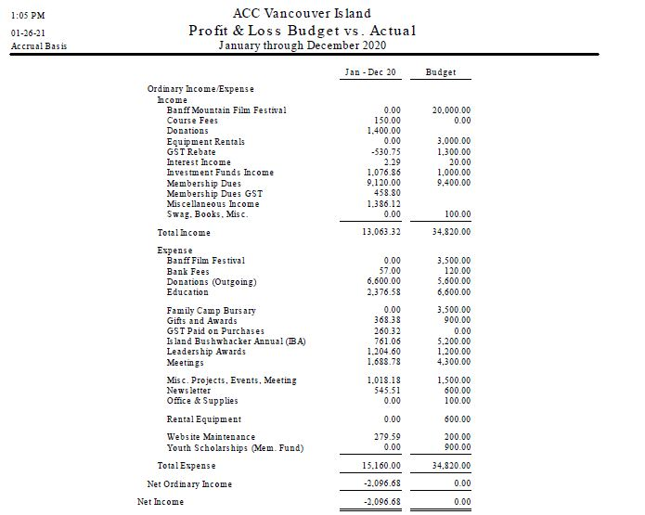
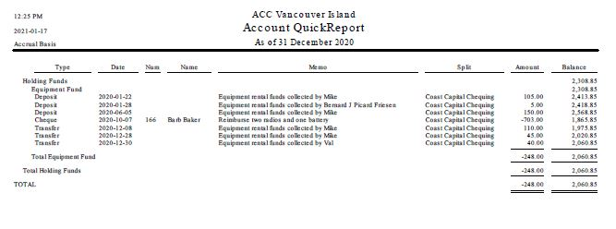
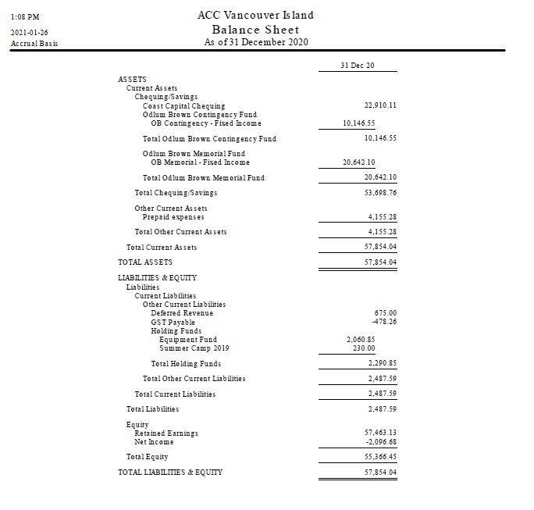
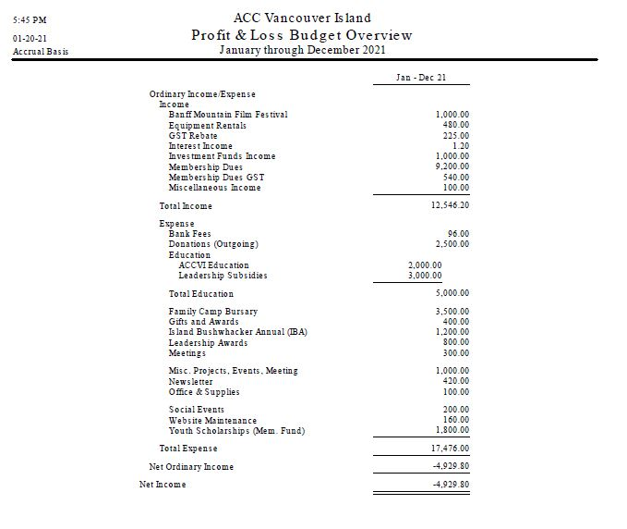

STATUS OF ACC-VI FUNDS effective 31 Dec 2020: Geoff Bennett
(Revised on 24 Jan 2021 after the ACCVI Executive declined to match the 2020 donation to the MF)
MEMORIAL FUND
• The purpose of this fund is to disburse youth grants every year to deserving applicants. The capital value of the fund (donations plus Section contributions) must not be encroached. Section contributions are in effect a long term loan from the Section to the MF. In an emergency, the Section funds can be reclaimed from the MF. Since 2018, the Section has offered $1,000 in youth grants each year, regardless of the underlying Fund performance. If the Fund yields less than $1,000 then the Section makes up the balance.
• Year end 2020 balance $22,422.80
o $20,642.10 book value of corporate bonds in Odlum Brown account
o $780.70 cash in OB account
o $1,000 pending deposit from ACCVI (total of 2020 donations but no matching contributions)

• Total donations and matching section contributions since 2009: $21,230
o This is the capital in the Memorial Fund

• Total disbursements since 2009: $8,875 on 11 projects o $7,694 from the MF
o $1,181 from ACCVI Section in the form of a top-up
o The two projects in 2020 were cancelled owing to the pandemic

• Total investment return since 2009: $9,668
• Funds available for disbursement in 2021: o Current balance in MF ($22,423) less capital ($21,230) = $1,193 available
o However, the cash balance is $781 so this is the actual amount that can be liquidated
o Funds left over from cancelled projects in 2020 = $780
o Therefore, funds available for disbursement = a minimum of $1,561 and a maximum of $2,000 (if additional ACCVI funds are needed)

CONTINGENCY FUND
• The purpose of this fund is to hold $10,000 in reserve for emergencies and to generate annual income for the Section.
• Original investment (2009): $10,000
  - • Year end 2020 balance in Odlum Brown account $10,414.51 o book value of corporate bonds (2): $10,118.35
  - o cash: $296.16 (available for deposit to the ACC Coast Capital account)

INVESTMENTS
• The CF and MF invest in the following corporate bonds through Odlum Brown:
• JOHN DEERE CANADA 2.05% 13MAY22 o John Deere manufactures agricultural, construction and forestry machinery, diesel engines, drivetrains (axles, transmissions, gearboxes) used in heavy equipment, and lawn care equipment. The company also provides financial services and other related activities.

• ALLIED PROPERTIES REIT SR B 3.934% 14NOV22 o A leading owner, manager and developer of (i) distinctive urban workspace in Canada’s major cities and (ii) network-dense urban data centres in Toronto that form Canada’s hub for global connectivity. Allied’s business is providing knowledge-based organizations with distinctive urban environments.

• GRANITE REIT Holdings Limited Partnership 3.873% S3 30NOV23 o A Canadian-based Real Estate Investment Trust (REIT) engaged in the acquisition, development, ownership and management of predominantly industrial, warehouse and logistics properties in North America and Europe. Granite owns over 85 investment properties representing approximately 33 million square feet of leasable area.

Since inauguration of the Memorial Fund in 2009, ACCVI has disbursed $8,875 to 11 different youth groups in the alpine (not including the two cancelled projects in 2020):
• 2010 - $1,200 for the Brooks Peninsula Expedition (Gillian Nicol, Cory McGregor, Cody Gold, Derek Cronmiller)
• 2012 - $250 for first ascents on the SW Buttress of Mount Arrowsmith (James Pierzchalski)
• 2013 - $1,400 for a General Mountaineering Camp for youth at Mount Matchlee (Harry Steiner)
• 2013 - $600 for a first ascent of North Needle Peak in the Great Bear Rainforest (Christina Service, Laura Grant, Vernon Brown)
• 2015 - $925 for a study of weather conditions and climate change at 20 remote fire lookouts in the Rockies (Kristen Walsh)
• 2016 - $1,500 to purchase climbing gear for a First Nations youth rock climbing camp near Ucluelet (Carlos Mack)
• 2018 – $2,000 total

$700 for a Strathcona Park traverse including first winter ascents of Tom Taylor and Mariner (Evan DeVault)
$600 for a S-N hike of the entire VI Spine Trail (Isobel Glover)
$500 for a ski tour of Liberty Bell, Washington by the ACCVI youth group (Derek Sou)
$200 to purchase equipment for an expedition by Nanaimo Scouts to climb several major peaks in the UK (Andy Chapman-Coombs)
• 2019 - $1,000 for a bike trip and climb by the ACCVI youth group of Mariner Mountain from Bedwell Sound (Derek Sou)
• 2020 - $1,000 approved in total but both projects were cancelled owing to the pandemic

$800 to hike the length of the VI Trail as a diabetic and to film the project (Nick Noble)
$200 to forage for wild plants and to prepare a gourmet meal (Vanessa Barr)

