Draft Minutes: ACC – VI Executive Meeting
Tuesday 30 April 2019 7:00pm
______________ _4078C Cedar Hill Rd., Victoria (chez Jeff Beddoes)____________________
Present: Catrin Brown, David Lemon, Brianna Coates, Alois Schonenberger, Geoff Bennett, Derek Sou, Martin Hofmann, Jes Scott, Anya Reid, Bernard Friesen
Skype: Clarke Gourlay, Barb Baker, Christine Fordham
Meeting called to order at 7:16pm.
- Adoption of the agenda
Motion: Accept with Karun’s addition. Moved: David Lemon; Second: Brianna Coates. Carried

- Adoption of the minutes of the executive meeting of 28 February 2019
Motion: Anya Reid; Second: Derek Sou. Carried.

- Treasurer’s Report: Clarke
See attached statements (balance sheet, profit & loss budget vs. actual).
Overall finances are good, with no concerns, however some budget items will go over their planned amounts. Most of the current year’s Bushwhacker allocation was spent on completing last year’s edition (charged to this year’s budget). Course subsidies will also go over, as the current year’s allocation has already been spent. The FMCBC membership charge will also be more than budgeted, because of the increase in section membership. The club has a good reserve, and may be able to realize some savings elsewhere, although publishing the current year’s Bushwhacker will be costly. The increases in all three of the above costs are being driven by rising membership, and only 25% of our income is from membership fees (the majority comes from the Banff Mountain Film Festival profit).
The cost increases could be addressed in several ways:
Require leading more than 1 trip to qualify for a course subsidy. (Brianna is compiling statistics to see how many trips people have been leading.)
Motion: Effective July 1st, 2019, to claim the course subsidy of up to $300, a minimum of two trips must be led within 1 year of completing the course (recipients of subsidies for the North Face course must lead three trips). Moved: Martin Hofmann; Second: Derek Sou. Carried unanimously.
Consider issuing next year’s (2020) Bushwhacker in electronic form, with an additional charge for a print version. For the current year, issue it in print form, but with an option for recipients to choose an electronic version instead. Jes will set that up, and members will be informed by email and in the newsletter.
FMCBC dues payment of $2500 will be due in July if the section decides to continue its membership.
Christine suggested raising the ticket price for the BMFF, as other venues already charge more than we do, and it sells out quickly. Adding an additional showing won’t be possible for a year at least, as the schedule is set far in advance.

- CRD Parks Alois
Alois attended the CRD meeting held to obtain input from user groups on plans for the Sooke Hills Wilderness regional park. Current plans include a parking lot at the Sugarloaf trailhead, as well as a trail map to be issued soon. The CRD parks staff noted that most potential user groups have associations (e.g. mountain bikers, horse riders, etc.) but rock climbers don’t, so they find it difficult to contact them for input. Alois and others are working on forming a South Island Climbing Society to focus on local access issues for rock climbing sites rather than alpine access. They hope to register the society in the summer and have the first AGM in the fall (they are working with the Climbers Access Society of BC).

- Incident Reporting Brianna
Brianna proposed having an incident form for the section (in addition to the one required by National) for information and learning, with the idea that it would be submitted for actual incidents or near-misses, to promote reflection on the causes and ways to prevent recurrences. The consensus was that it is a good idea, but the technical details to implement it will need to be worked out. Brianna will report on progress at the next meeting.
A proposed new addition to the website, Geoff’s anthology of “Close calls” may fit appropriately in this part of the site.

- North Face Application Process Brianna
Both ACCVI applicants were accepted. Brianna is on the selection committee and has some suggestions for the section executive when considering endorsement for applicants. She will circulate these when the next applications are up for consideration. (Brianna’s post meeting notes attached)

- Hut Committee Update Martin
Weekends are fully booked until September. Most things at the hut are working OK, and some funds are coming in for the wind turbine and other improvements. We now have a hut access manager, Gary Croome.

- Access and Environment Barb
MOSAIC is the new operations management for both Timberwest & Island Timberlands forestry. Their community outreach team asked for a meeting to introduce VP Domenico Iannidinardo to which Catrin and other locals attended April 15. Lengthy meeting during which they used the term “permanent corridors to public spaces”. This is new. Domenico asked our assistance in helping them offload liabilities if their roads were to be used in that way. Neither ACRD or CVRD or MLA Scott Fraser’s office have been approached in this way. Since the meeting Catrin has had further communication with Domenico, nothing substantial. But the notes of our 2017 meeting have been located and we have been asked to suggest an area for an interim pilot access agreement. I will suggest CX91, an access into the Beauforts: Apps, Joan, Squarehead & may include AVOC who have more of an interest in that area.
Recreation access blog (navigate through Island Timberlands recreation access) seems to be reliable.
Snow level up to Rousseau Chute on Cokely. Many new roads have been built on Cameron and Pass Main. We will live to see the whole valley logged again.
Inlet Trails Stage 1 & 2: IT harvesting complete and Stage 1 trails reconnected. Have not checked Stage 2. Looks like a moonscape.
Runners’ Trail (part of VISTA): WFP working on Parsons Creek bridge where hikers might need to go around. In future there will be logging beyond Francis Lake. Trying to get WFP & VISTA to communicate directly on these areas.
FLNRO BCTS: Wesley Towers Trail at the east end of Cameron Lake is very heavily used. Map tech has ascertained that that unauthorized trail is on Crown land. Good news.
Not sure if the logging operations on Br.600 to Klitsa are complete. Access had been impeded there during the day.
Toilet sign to be installed at Triple Peak trail head is ready to go.
Della Falls: if we have more interest in winter ice climbing, a water taxi service would be useful

- National Club Christine
Information on Respect the Mountains Day has been circulated. The initial idea for ACCVI participation fell through because of permit issues with BC Parks. Now looking at Mt. Washington as the site for a cleanup and education day. Will need a $200 budget for possible costs, and Christine will circulate information once the plan is firmed up.
We usually make a $100 donation to the Canadian Alpine Journal; agreed that we should continue to do so, and Christine will inform Clarke.

- FMCBC Anya
Anya reviewed the situation: is it too expensive at 50% of our membership fees for what it does for our issues, or is the advocacy it does on larger issues important enough to continue membership? If we were to leave, what should be done with the money that had been going to FMCBC fees? There has been a limited amount of feedback from the membership, with mixed opinions. Catrin has had further communication with Barry Janyk, previously circulated.
The plan is to have a formal vote by the executive on retaining membership or not, which will be done by email. An information package will be circulated with the notice of motion.
Motion (to be voted by email): That ACCVI terminate membership in FMCBC effective 31 May 2019. Moved: Christine Fordham; Second: Jes Scott.

- Summer Camp Update Jeff
The camp is nearly full for all four weeks (only 1 or 2 spots remain to be filled). The priority registration system worked well for this year; consideration of whether to use it in future postponed until the next meeting.

- Island Bushwhacker Annual 2018 Update Catrin for Rob
Submissions are 34 Articles, 123 images. There are probably going to be another 4-5 articles taken from the 2018 Newsletters. The edition will likely be 100 pages or more.
Costs to print are likely to be $3200 + GST for a run of 450 copies plus a galley to check up front. Rob has edited all the text and converted all the pictures to size/B&W so is pretty close to the place to rent Adobe InDesign and start to input all this material to make the Issue. Layout to folow.

- First Nations Liaison Update Geoff See previously circulated and attached report.

- Next Meeting: To be determined.
- Meeting adjourned at 9:48 pm

Attachments

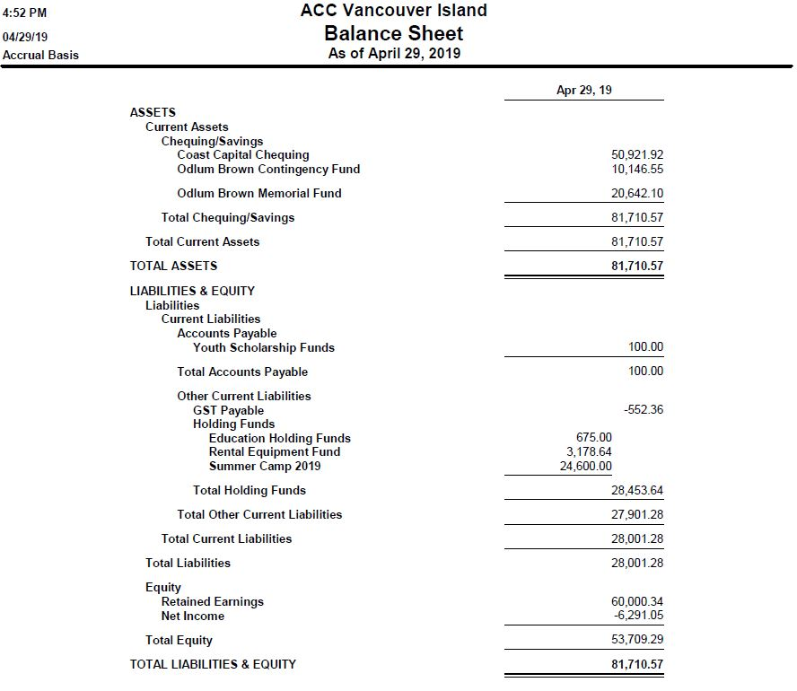

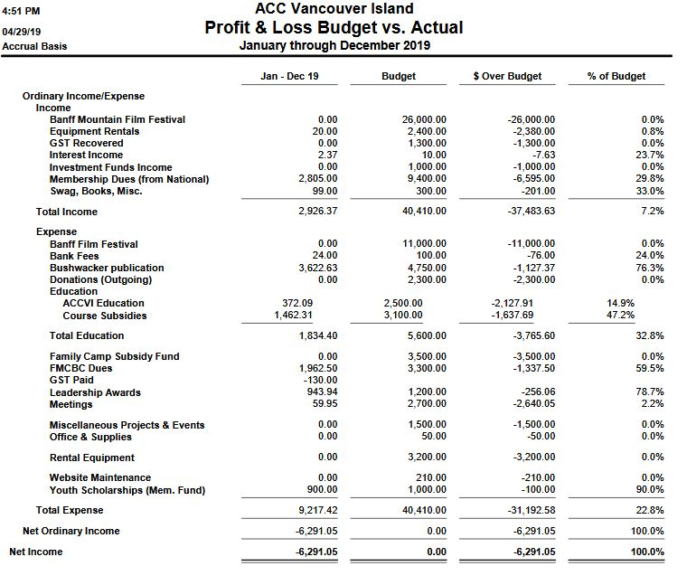

Agenda item 6: Questions to ponder when reviewing North Face Leadership Applications for Endorsement
Brianna Coates
Is the applicant clear about why they want to take the course? Are their reason(s) keeping with the spirit of the course which is to provide training to those wanting to give back to the Club by becoming trip organizers or enhance their skills as current trip organizers?

Are they a new or emerging leader, and if not (ie, have been a long time leader) are they clear about why they think they would benefit from the course? This helps to assess people who apply but have been leading trips for a long time. In this situation it’s helpful to understand “why now”?

Is there a course that would better serve them? Do they need to take a more basic course to up their skills or is the TNF course too basic for them? For those really keen on becoming a guide or very experienced amateur leaders, the Karl Nagy scholarship application might be more appropriate.

Are their goals for giving back to the club realistic and match their abilities, knowledge and experience?

Have they shown commitment to the club already by either leading or co-leading trips, slide shows, education courses or participating in a variety of trips? If they haven’t shown this do they acknowledge they have yet to show commitment?

Does this person’s skills and knowledge outside of climbing/skiing fill a gap in our section leaders?

Am I being objective in my analysis of the application? Do I really like this person but have some hestancies about their abilities as a leader? Or do I not like this person but can’t find anything to objectively criticize? Am I being influenced by other people who know the applicant and like/don’t like them?

Is there a chance that English is not their first language or the written word is not their forte? This helps to assess applications that are not as full-some or well written.

Agenda item 13: Report of the First Nations Liaison Subcommittee
For the ACCVI Executive meeting – 30 April 2019
By Geoff Bennett (coordinator)

Subcommittee Members (names and roles):
- Rob Ramsay (working with FN youth and elders; climbing leadership)
- Brianna Coates (working with FN youth; climbing leadership)
- Iain Sou (working with FN youth; climbing leadership)
- Vanessa Barr (working with FN youth; climbing assistance)
- Zoe Minnaard (working with FN youth; climbing assistance)
- Jesse Whitehead (working with FN youth)
- Colin Mann (climbing education)
- Derek Sou (liaison with ACCVI youth)
- Mary Sanseverino (communications)

Other advisors, helpers and interested people:
- Chris Jensen (hut naming and bookings for FN groups)
- Barb Baker (access and politics)
- Alois Schonenberger (education; experience with FN youth)
- Krista Gooderham (climbing)
- Colin Robinson (Tofino contact – climber, ACC member, local FN experience)
- Tristan Oliver (video documentary of hut and FN youth)
- Karin Olafson (freelance journalist with an interest in ACCVI initiatives, including FN)

Main FN contact
- Ricardo Manmohan (Warriors Youth program coordinator in Tofino/Ucluelet)

Warrior Youth Games, Effingham Inlet, 17-19 May
- Rob, Brianna and Krista attempted a recce of the area on 13 April but the sea was too rough for the boat. The next recce attempt will be 5 May. The objective is to find a suitable cliff face to teach FN youth basic rock climbing and rappelling during the Games.
- Climbing instructors will be Rob and Iain with assistance from Vanessa. We are searching for two more people, preferably with climbing experience.

Alpine gear for FN youth
- An appeal went out in early April to ACCVI members for donations of boots and other alpine gear. There were four drop-off points in Victoria, Duncan, Parksville, Comox.
- Brianna and Rob delivered 2 bins and three backpacks full of boots and gear to Ricardo on 13 April.
- The gear was well-received, although Brianna noted that in the future we should not accept old harnesses.

July weekend at the hut – snow school for FN youth
- No plans yet; waiting on Ricardo to settle on a date

October weekend at the hut – combined FN Warriors youth and ACCVI youth
- Booking made for 4-6 Oct, courtesy Chris Jensen
- Tentative plans include hiking, scrambling and a hut naming ceremony
Hut naming
- Following a suggestion from Chris, we have asked Ricardo to approach various FN elders and youth regarding a name for the hut. This is difficult because the hut is located near the intersection of six FN territories. Ricardo is willing to try and has been given photos and videos of the hut to show to interested people.
- If and when a name is proposed, it will be presented to the ACCVI exec for approval before planning a naming ceremony.

ACCVI climbing waivers
- After much discussion we have agreed to use our two standard waivers for each event, beginning with the Warrior Games. This is the same procedure that we use for ACCVI youth.
- The waivers will be sent to Ricardo by email before each event. He will arrange to get guardian and parental signatures.
- It would be preferable to have one simple waiver that covers all the points in the two existing forms. Would it be possible to draft a new version that we could send to the insurance people for approval?

Media
- Tristan Oliver is producing a video on the hut. He is also keen to include some footage of ACC activities involving FN, for example the Warrior Games and one of the hut weekends.
- Karin Olafson is a freelance journalist who is interviewing various ACCVI members in order to prepare a magazine article. Her particular interests are ACCVI activities involving First Nations, new immigrants and the disabled.

Politics
- Barb Baker has noted that both the federal MP (Gord Johns, NDP) and the provincial MLA (Scott Fraser, NDP Minister of Indigenous Affairs & Reconciliation) in the area of the 5040 hut have an interest in First Nations. She suggests that, if and when the ACCVI-FN relationship progresses, that we should notify them. Chris Jensen has some specific projects in mind which could be funded by government.

